Three Ring Circuits
Teacher notes

- Time needed to complete lab: This lab should take approximately 90 minutes.

- Target grade level: This activity is designed primarily for middle school students but could easily be adapted for other audiences.

- Objectives: At the conclusion of this activity the students should be able to describe in detail what makes a circuit, the purpose of resistors, and how a switch works.

- Major concepts: Electricity flows from negative to positive. An electrical circuit is a closed loop. You can change the amount of power flowing to an object by using a resistor.

- Preparation: Conductive and insulating dough should be prepared ahead of time. See recipes Attachment A. Holes should be drilled in the containers ahead of time. Our switches required a ¼” drill bit.

- Typical results or sample data: See attachment B.
Attachment A

Conductive Dough Recipe
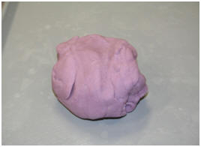
Materials:
1 cup Water
1½ cups Flour
(A gluten free version of this dough can be made by replacing the flour with gluten-free flour.)
¼ cup Salt
3 Tbsp. Cream of Tartar*
1 Tbsp. Vegetable Oil
Food Coloring (optional)
*9 Tbsp. of lemon juice may be substituted

Procedure:
1. Set aside ½ cup of the flour. Mix water, the remaining cup of flour, salt, cream of tartar, vegetable oil, and food coloring in a medium sized pot.
2. Cook over medium heat and stir continuously.
3. The mixture will begin to boil and start to get chunky.
4. Keep stirring the mixture until it forms a ball in the center of the pot.
5. Once a ball forms, place the ball on a lightly floured surface. WARNING: The ball will be very hot. We suggest flattening it out and letting it cool for a couple minutes before handling.
6. Slowly knead the remaining flour into the ball until you’ve reached a desired consistency.
7. Store in an airtight container or plastic bag. While in the bag, water from the dough will create condensation. This is normal. Just knead the dough after removing it from the bag, and it will be as good as new. If stored properly, the dough should keep for several weeks.

Insulating Dough Recipe

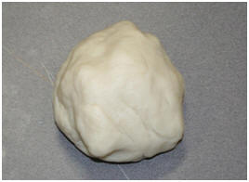
Materials:
1½ cup Flour
½ cup Sugar
3 Tbsp. Vegetable Oil
½ cup Deionized (or Distilled) Water(Regular tap water can be used, but the resistance of the dough will be lower.)

Procedure:
1. Set aside ½ cup of the flour. Mix the remaining flour and sugar and oil in a pot or large bowl.
2. Mix with this mixture a small amount of deionized water (about 1 Tbsp.) and stir.
3. Repeat this step until a majority water is absorbed by the mixture.
4. Once your mixture has reached a crumbly consistency, knead the mixture into one “lump”.
5. Knead more water into the dough until it has a sticky, dough-like texture.
6. Now, knead in flour to the dough, until desired texture is reached.
7. Store in an airtight container or plastic bag. While in the bag, water from the dough will create condensation. This is normal. Just knead the dough after removing it from the bag, and it will be as good as new. If stored properly, the dough should keep for several weeks.
Attachment B

In the first ring:

A simple circuit using the dough might look like this.

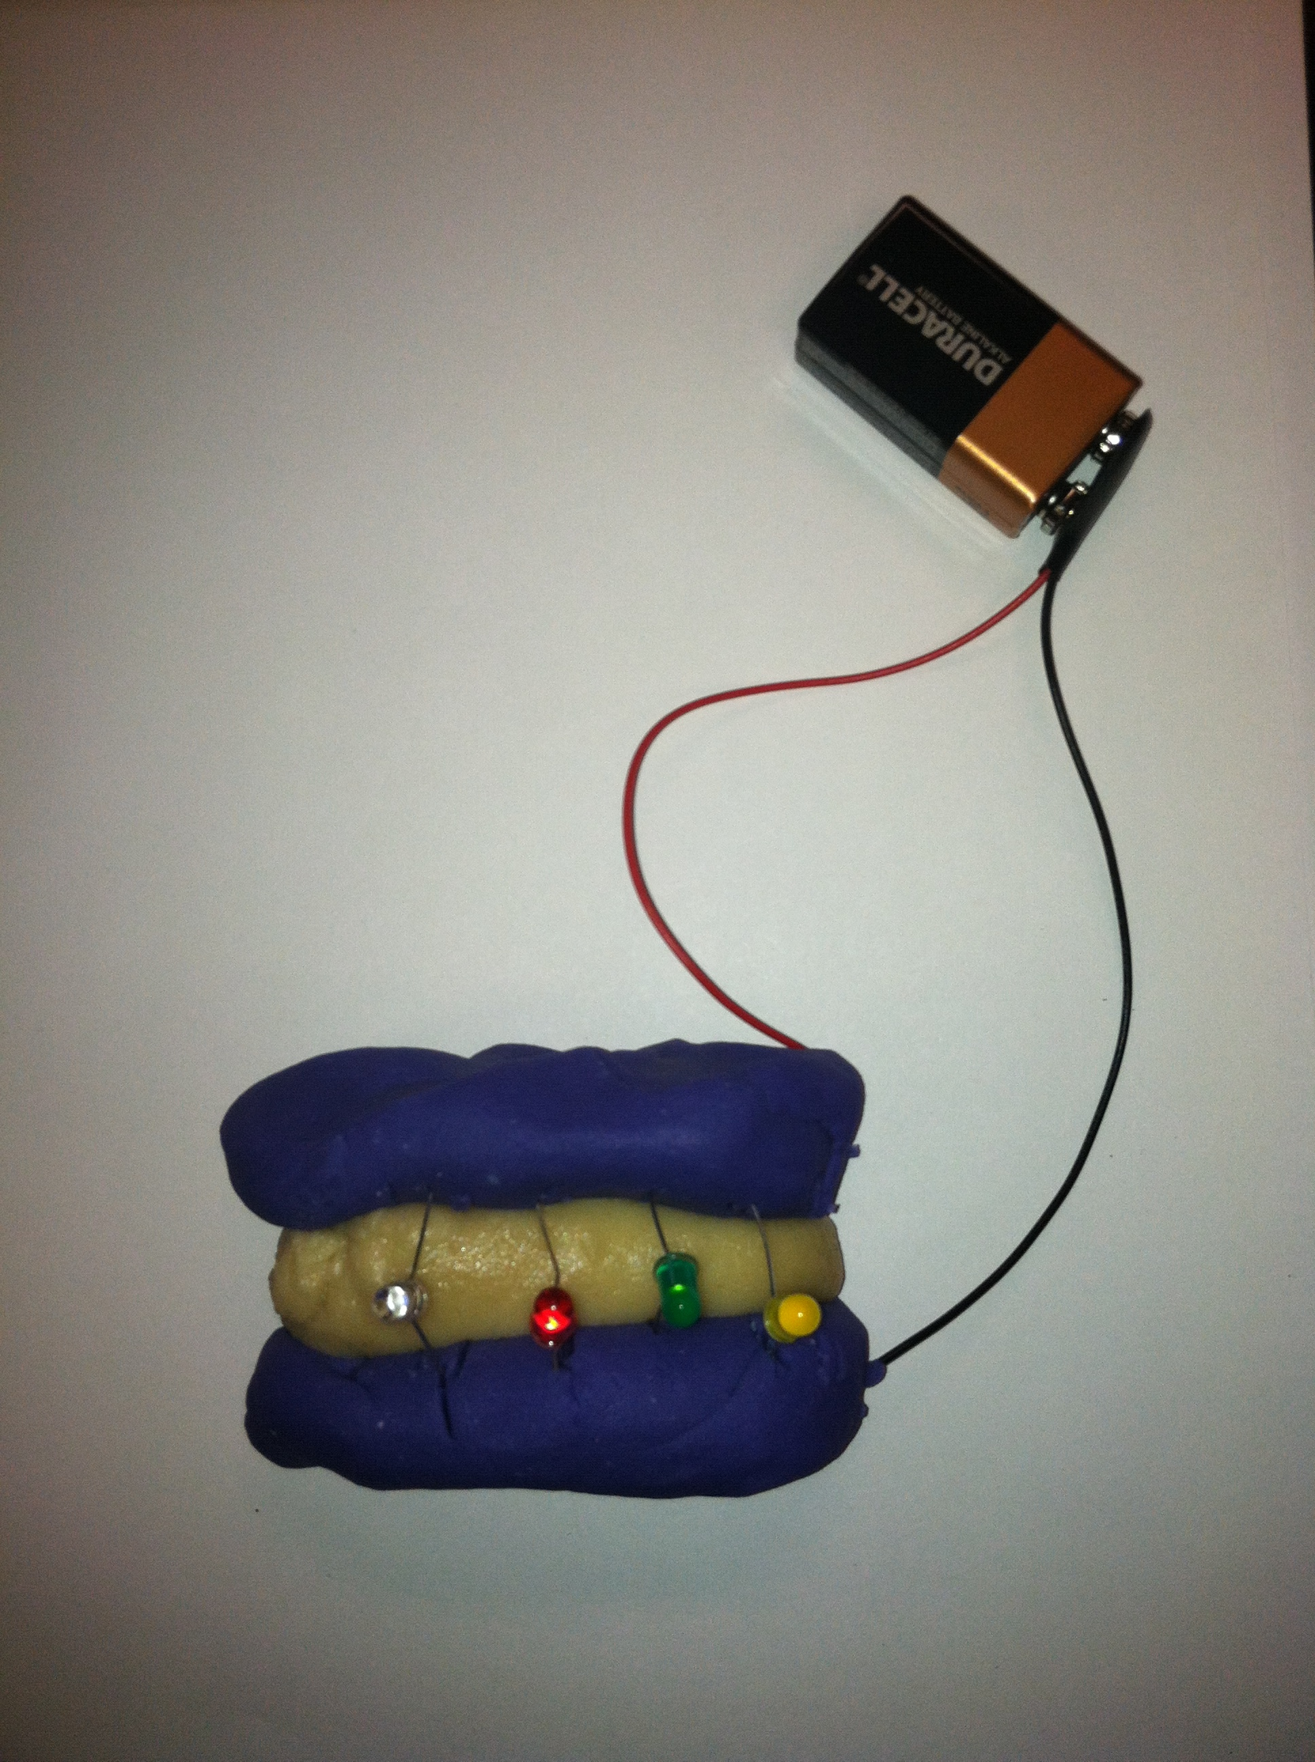

In electrical symbols, it should look something like this: (there may be more bulbs included in students’ diagrams)

