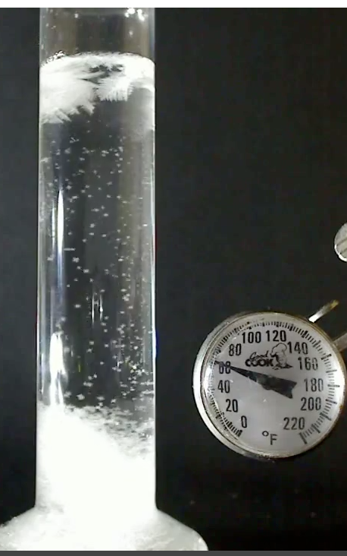
Storm Glass: Preparation
Teacher Notes

Time: 15-20 minutes

Grade level: Middle school, high school, or scaled down for elementary school

Objectives:
- To understand how temperature and pressure affect solubility and crystallization of a salt
- To investigate freezing point depression when solutes are added to a solvent
- To discuss how temperature affects the solubility of gases and the vapor pressure of volatile liquids
Storm Glass

Major Concepts:
- The effect of temperature and pressure on solubility
- Freezing point depression
- Vapor pressure depression

Answers to Discussion Questions:
- What is a barometer? A scientific instrument used in meteorology that involves changes in atmospheric pressure.
- What is the difference between weather and climate? Weather is the local changes in temperature, pressure, and precipitation while climate is average weather pattern in an area over time.
- What type of instrumentation is used to predict the weather today? Barometers, thermometers, hygrometers, anemometers, computers, satellites, weather balloons help us predict the weather today.

Preparation:
Each recipe for storm glass can be divided among four students. Provide each student with a copy of the interpretation of the storm glass provided at the end of the teacher’s notes.

Typical Results:
What does the storm glass look like when it is heated in a 40Cº warm water bath?
When heated, no precipitates or crystals remain in the storm glass when warmed in the warm water bath.

What does the storm glass look like when it is placed in an ice bath for 2-5 minutes?
When cooled, precipitates or crystals from in the storm glass.

Questions:
- What are two limitations to checking the workings of the storm glass in the laboratory? The conditions in the laboratory might differ from the actual atmospheric conditions outside the laboratory. The storm glass is a predictor of weather, not something that can be checked on the day of preparation.

- Is there a strong correlation between the workings of temperature and solubility in the components of storm glass and its ability to act as a weather predictor? Explain. Yes, there is a strong correlation. When the temperature increases, the salts in the mixture dissolve and so the glass becomes clear. When temperature decreases, the salts precipitate out of solution and the glass becomes cloudy.
PREDICTING THE WEATHER WITH STORM GLASS

- Liquid in the glass is clear, the weather will be bright and clear
- Liquid is cloudy, the weather will be cloudy, perhaps with precipitation
- Small dots in the liquid, indicate humid or foggy weather
- A cloudy glass with small stars indicates thunderstorms
- Liquid has small stars on sunny winter days, indicates snow is coming
- Large flakes throughout the liquid, indicates overcast days in temperate seasons or snowy days in the winter
- Crystals at the bottom indicate frost
- Threads near the top indicate windy weather.

- What three components of storm glass can vaporize? How would this affect the pressure inside the container? The ethanol, water, and camphor have high vapor pressure. So when temperature changes, the vapor pressure of the mixture changes.

Sources:
Fitzroy’s Storm Glass. About.com Chemistry. <<http://chemistry.about.com/od/weirdscience/a/fitzroy.htm>>
Fitzroy’s Storm Glass and Temperature. <<http://www.youtube.com/watch?v=NIhQ0aOFp9Q>>

Extension Activities:
Perform labs that investigate colligative properties (vapor pressure depression, freezing point depression, boiling point elevation)

Card with instructions on predicting the weather:
Part A: Solubility vs Crystallization

Time: 15-20 minutes

Grade Level: Middle school, high school, or scaled down for elementary school

Objectives:
- To define the terms temperature and solubility
- To identify the factors that affect solubility
- To identify the forces that hold substances together

Major Concept:
- Solubility vs Precipitation

Answers to Discussion Questions:
What is temperature? Temperature is the average kinetic energy of particles.
What is a solution? A homogeneous mixture of solute and solvent is called a solution.
What are the factors that affect solubility? Temperature, pressure, size of particles affect solubility.
What types of forces hold particles of a solute together? Solute particles are held by intermolecular and intramolecular forces.
What do the terms endothermic and exothermic mean? The term endothermic means heat is absorbed in the system and exothermic means that heat is released from a system.

What is a saturated solution? How can you supersaturate a solution?
A saturated solution is a solution that has the maximum amount of a solute in the solvent. By changing pressure and temperature a supersaturated solution may be created to dissolve more than the maximum amount of solute in a solvent.

Typical Results:
All the solute will not dissolve in the initial dissolution. Swirling the test tube and its contents after heating it in the water bath should dissolve all the solute. Fine crystals should from when the test tube is placed in the ice bath.

Questions:
- Is the above change physical or chemical? How do you know? Solubility is a physical change here because no chemical reaction is taking place.
- Why did you have trouble dissolving the salt after a while? The salt solution is saturated with the salt and cannot dissolve any more at that temperature.
- Is the above change exothermic or endothermic? Explain. The test tube gets cold and the temperature drops as energy is absorbed to dissociate the ions of the salt in the solvent forming the solution.
- Explain your observations in the warm water bath. When temperature increases, energy is given to dissociate any salt particles that did not dissolve in the solvent.
- Explain your observations in the ice water bath. When temperature drops, any salt that did dissolve in the solvent drops out of solution and crystallizes.
- Make a generalization, how does temperature affect solubility and crystallization? Increase in temperature can increase solubility and decrease in temperature can increase crystallization of a salt.

Sources:
Temperature and Pressure Effects on Solubility. <<http://www.elmhurst.edu/~chm/
vchembook/174temppres.html>>
Fitzroy’s Storm Glass. About.com Chemistry. << http://chemistry.about.com/od/ weirdscience/a/fitzroy.htm>>

Extension Activities:
Illustrate and discuss solubility rules using the above lab set up with different salts.

Make a barometric instrument called a storm glass and discuss how temperature and solubility might affect the changes in the glass.

Part B: Vapor Pressure Depression
Time: 45 minutes - 1 hour

Grade Level: Middle school, high school

Objectives:
- To define vapor pressure
- To identify volatile vs non-volatile substances
- To understand equilibrium and vapor pressure
- To explain vapor pressure depression in a graphing exercise involving vapor pressure

Major Concepts:
- Vapor pressure depression or Raoult’s Law
- Ideal vs non ideal solutions

Answers to Discussion Questions:
What is an ideal solution? A solution where intermolecular forces between solute and solvent are minimal or weak is said to be ideal.

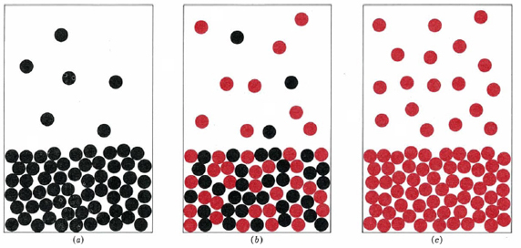
What is a non-ideal solution? The vapor pressure of non-ideal solutions deviates from Raoult’s Law. The deviation has to do with intermolecular forces between solute and solvent. If forces are attractive, the deviation will be negative. If forces are repulsive, the deviation will be positive. Solution formation in the first is exothermic, and in the second it is endothermic.
ab c

What is a volatile liquid? A volatile liquid is a liquid that evaporates easily. It is a chemical with high vapor pressure under standard conditions of 25ºC and 1 atm.

Among liquids, solids, and gases, which is considered non-volatile? Solids.

What is an example of a solid that is very volatile at 25ºC and atmospheric pressure? Dry ice.

Preparation:
To make a 50% solution of ethanol from a 95% ethanol solution. Take 95mL of the 95% ethanol and add water to make 190 ml. Scale up or down as needed. Setting up the computer before the lab will cut down on time to execute the lab.

Questions:
- Is the mixture of ethanol and water considered ideal or non ideal? Explain. The mixture of ethanol and water are considered non ideal because intermolecular forces exist between the ethanol and water and both are considered volatile liquids.
- How do the three graphs compare? What seems to happen to the vapor pressure as time goes on and the temperature is steady? The vapor pressure of the water is the lowest, while vapor pressure of the ethanol is the highest, and the vapor pressure of the mixture lies somewhere between the two values.
- Choose a temperature on your graph and calculate the atmospheric pressure at this temperature? Use P₁/T₁ = P₂/T_{2 .} Convert ºC to Kelvin. Temperature = 22.6 ºC. 741.9mmHg / 293.2 K= P₂ / 295.6K. P₂ = 748.0 mmHg
- Calculate the partial pressure of the ethanol the above temperature using P_{T} = P_{air} + P_{ethanol.} 791.6 = 748.0 + P_{ethanol.} P_{ethanol} = 43.6 mmHg
- Calculate the partial pressure of the water at the above temperature using P_{T} = P_{air} + P_{water.} 757.4 = 748.0 + P_{water.} P_{water} = 10.4 mmHg
- Calculate total pressure of the solution using P_{solution} = P_{air} + 0.77 P_{water} + 0.23P_{ethanol.}
- P_{solution} = 748.0 + 0.77 (10.4) + .23 (43.6) = 766 mmHg (Pressure of the 50% ethanol mixture should be close to this value at 22.6 ºC.
- What have we kept constant in this experiment? Volume is kept constant.
- If the syringe expands in volume what might happen to your pressure? The pressure will decrease and a new equilibrium vapor pressure will be established.

Sources:
Raoult’s Law. <<http://chemed.chem.wisc.edu/chempaths/GenChem-Textbook/Ideal-
Solutions-Raoult-s-Law-850.html>>
Fitzroy’s Storm Glass. About.com Chemistry. << http://chemistry.about.com/od/ weirdscience/a/fitzroy.htm>>

Extension Activities:
- Identify the other colligative properties and perform experiments and demonstrations to illustrate these properties.

- Make a barometric instrument called a storm glass and discuss how vapor pressure depression might affect the changes in the glass.

Credits:
A big thank you to chemistry mobile educator Tara Yorke, and lab assistants Christian Hague, and Feiyang Xu of Juniata College’s Science in Motion for help in developing this lab.

Part C: Freezing Point Depression

Time: 45 minutes

Grade Level: Middle school, high school

Objectives:
- To define freezing point
- To identify freezing point depression as a colligative property and to explain how it works
- To identify the units of molality
- To understand how salts dissociate into ions when they dissolve in a solvent
- To describe how the Van’t Hoff factor is determined

Major Concepts:
- Freezing point depression
- Colligative properties
- Ion dissociation

Answers to Discussion Questions:
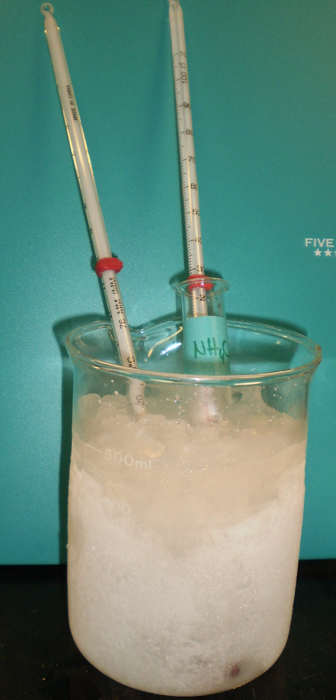
- From the equation above, what is the relationship between change in temperature and the concentration, and change in temperature and number of particles?
The change in temperature or freezing point depression depends on the number of particles and the concentration. There is a directly proportionate relationship.

- What is a colligative property?
A colligative property is a property of matter that depends on the number of particles in a substance. All liquid solvents that have a dissolved solute experience colligative properties. The other colligative properties are boiling point elevation, vapor pressure depression, and osmotic pressure.

Sample Data:
Salt | Mass of Beaker (g) | Mass of beaker + water (g) | Mass of water (g) | Mass of salt  (g) | Freezing point of water Cº | Freezing point of salt solution Cº | Change in freezing point Cº
NH₄Cl | 115.66 | 164.49 | 48.85 | 2.70 | 0.0 | -4.0 | 4.0
CaCl₂ | 113.88 | 163.20 | 49.32 | 5.50 | 0.0 | -6.0 | 6.0

Analysis and Conclusion:
- Which salt is supposed to depress the freezing point more? Why is this so?
- CaCl₂ is supposed to depress freezing point more than NH₄Cl because it puts three ions in solution as opposed to the two belonging to NH₄Cl.
- Did your results match the expectation? Why or why not? Answers will vary according to results.
- What will happen if both salts were added to the same volume of solvent? The Van’t Hoff factor would increase to about 5, according to the number of ions.
- What are some possible sources of error in this experiment? Using water with contaminants in it would alter final freezing point. Not recognizing actual point when it happens is another source of error.
- How would these salts change the boiling point of the solutions? What formula would you use? The boiling point would be higher. ∆T = K_{b}(m_{solution})(n_{i})
- Would freezing point of water change if I added sugar instead of a salt? Yes, the freezing point of water would change when adding sugar. The Van’t Hoff factor would = 1 for sugar.

Sources:
Raoult’s Law. <<http://chemed.chem.wisc.edu/chempaths/GenChem-Textbook/Ideal-Solutions-Raoult-s-Law-850.html>>
Fitzroy’s Storm Glass. About.com Chemistry. <<http://chemistry.about.com/od/weirdscience/a/fitzroy.htm>>

Extension Activities:
- Dissolve 10g of ethanol in 100g of water and discover the freezing point depression for ethanol in water. How is it different from discovering the freezing point depression of a salt in water?

- Graph a cooling curve for t-butanol (solvent) and ethylene glycol (solute) 0.5m. Do one trial to discover the actual freezing point of t-butanol and one trial to discover the freezing point depression for t-butanol with ethylene glycol. Record the temperature at 30 second intervals. Draw a graph of temperature (y-axis) vs time (x-axis) and extrapolate to find freezing point.

