Crystal Clear: Aluminum to Alum

Pennsylvania Standards:
Science and Technology
3.2.C.A1: Differentiate between physical properties and chemical properties. Differentiate between pure substances and mixtures.
3.2.C.A4: Predict how combinations of substances can result in physical or chemical changes, or both.
CHEM.A.1.1.1: Classify physical or chemical changes within a system in terms of matter or energy or both.
CHEM.B.2.1.1: Describe the roles of limiting and excess reactants in chemical reactions.
CHEM.B.2.1.2: Use stoichiometric relationships to calculate the amounts of reactants and products involved in a chemical reaction.
S11.A.1.1: Analyze and explain the nature of science in the search for understanding the natural world and its connection to technological systems.

Math Common Core
CC.2.1.HS.F.3: Apply quantitative reasoning to choose and interpret units and scales in formulas, graphs, and data displays.
CC.2.1.HS.F.5: Choose a level of accuracy appropriate to limitations on measurement when reporting quantities.

Reading Common Core
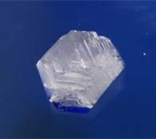
CC.1.2: Students read, understand, and respond to informational text — with emphasis on comprehension, making connections among ideas and between texts with focus on textual evidence.
Alum Crystal
CC.3.5.9-10.G: Translate quantitative or technical information expressed in words in a text into visual form (e.g., a table or chart), and translate information expressed visually or mathematically (e.g., in an equation) into words.

Introduction:
Alum or potassium aluminum sulfate dodecahydrate KAl(SO₄)₂.12 H₂O is a crystalline salt that is commonly used as a preservative in foods like pickles, as a drying agent in underarm deodorants, and as a flocculant in water purification. Used or scrap aluminum may be recycled by converting it into usable alum.

Guiding Questions:
- What are some signs of a chemical reaction?
- What is a salt? What is a hydrate?
- What is a mole?
- How is the purity of a salt determined?
- How can we differentiate between crystalline and amorphous solid?
- What is the difference between exothermic and endothermic reactions?
- What is the difference between a precipitate and a crystal?
- How many sides does a dodecahedron have?

Materials:
ice water-bath in a beaker or pan, aluminum foil, 12.0 mL of concentrated sulfuric acid, 8.00 g of potassium hydroxide, electronic scale, two 250 mL beakers, 100 mL graduated cylinder, filter paper, stirring rod, hot plate, pair of scissors, funnel, ring stand, mortar and pestle, Melt-Temp, closed-end capillary tube, glass-dropping tube, labeling tape

Safety:
Wear apron and goggles. Both sulfuric acid and potassium hydroxide solutions are highly corrosive: so, be very careful, and follow procedure when handling these chemicals. Always add acid to water when making up the acid solution. Rinse spills with plenty of water.

Procedure:
Part A
- Tare the scale and mass out 1.00g of aluminum foil. Use a pair of scissors to cut the aluminum foil into small pieces (the smaller, the better).
- Mass 8.00g of potassium hydroxide in a weigh boat, and place it in the 250 mL beaker. Use a graduated cylinder to add 50.0 mL of water to the potassium hydroxide in the beaker, and stir with a glass rod. Label the beaker, and place your name on the fume hood for 2 minutes until dissolved, and then place the beaker in an ice water-bath.
- Place 13 mL of water in a second 250 mL beaker, and very slowly add 12 mL of concentrated sulfuric acid. Label and place this beaker of solution in an ice water-bath until it cools.
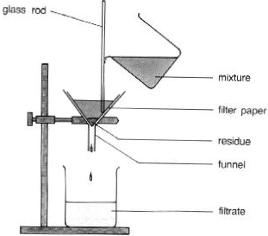
- Set up a ring stand with a funnel, and place the beaker with the acid solution under the funnel. (See the figure above on the right). Fold the filter paper into a quarter, slightly wet the paper, and place it in the funnel. Filter the KAl(OH)₄ solution through the filter paper. A white precipitate forms when the filtrate reacts with the acid solution.
Filtration Setup
- Place the beaker containing the white precipitate on a hot plate, and heat the product on low heat, and stir with the glass rod until it dissolves.
- Label the beaker and allow it to sit under the hood overnight undisturbed.

PART B
- Decant the crystals, and wash them down with water or ethanol, and allow to dry.
- Mass the dry crystals, and record the results.
- Calculate percent yield.
- Use the mortar and pestle to pulverize a small crystal
- Use a closed end capillary tube and a dropping tube to pack a small quantity of the alum in the capillary tube to a depth of 0.5 cm.
- Use a Melt-Temp to determine melting point of the solid. (See figure on Page 3.) Heat the Melt-Temp slowly.
- Observe your sample through the eye piece, and record the melting point range of your sample when the first droplets of liquid appear until the entire sample is melted, and record your results.

Data:
Mass of aluminum foil =
Mass of alum crystals =
Melting point of alum crystals =

Calculations:
- What is the formula mass of KAl(SO₄)₂.12 H₂O, based on the molar masses listed on the periodic table? [Hint: Add up the molar masses of each element in the formula.]
- How many moles of alum were produced in the experiment? [Hint: Divide the mass of alum obtained in the experiment by the formula mass.]
- How many moles of aluminum were consumed in the reaction? [Hint: Divide the mass of aluminum used in the experiment by the molar mass of aluminum on the periodic table.]
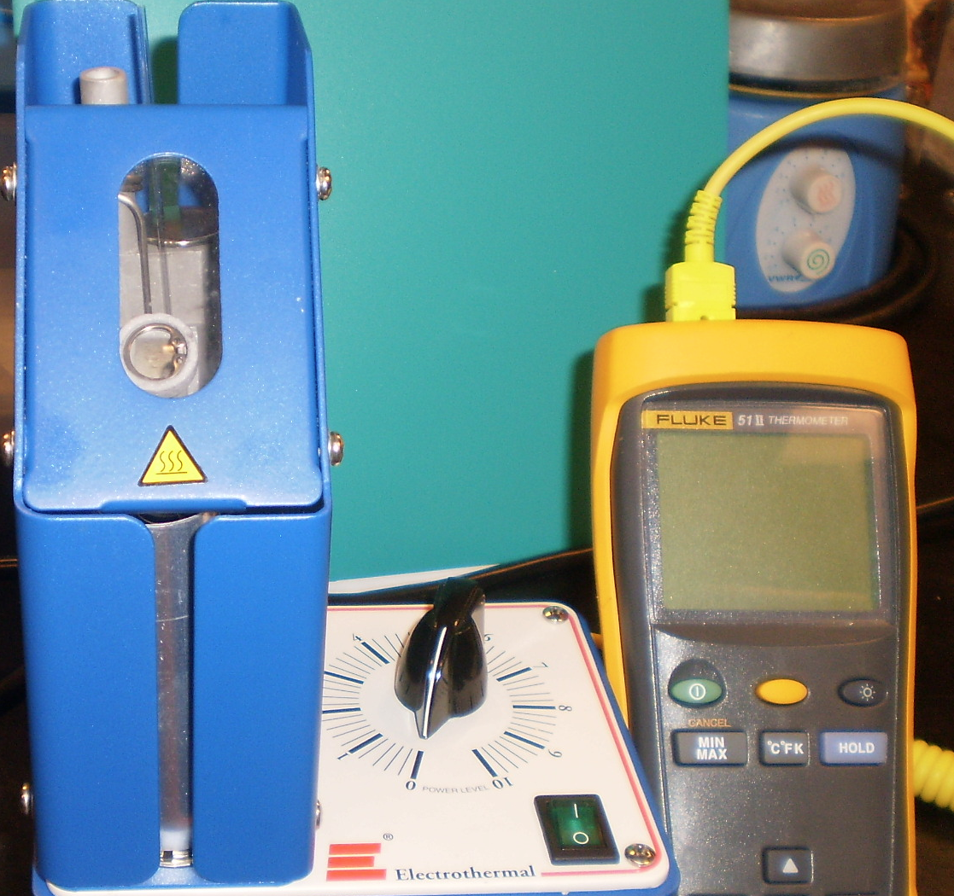
- For every mole of aluminum used, one mole of alum should be produced. Using your calculated value for moles of aluminum, how many moles of alum should you have obtained? [Hint: This value is your theoretical yield].
Melting Point Setup
- What is your percent yield of alum?

- %Yield = Actual Yield x 100 =
- Theoretical Yield
- Obtain the accepted actual melting point from your teacher, and calculate the percent error in the melting point.

- %Error = | Actual – Theoretical | x 100 =
- Theoretical
Questions:
- Why did the reaction get hot when sulfuric acid was added to the reaction mixture?
- What are two reasons for the experimental melting point being lower than the accepted actual melting point?
- If the alum crystals were wet when massed, how would they affect your yield?
Sources:
Science in Motion Lab on the Preparation and Verification of Alum
Synthesis of Alum. <<http://web.lemoyne.edu/~giunta/chm151L/alum.html>>

