Stan’s Salad
Standards:
3.2.10 A Integrate new information and explain implied results
3.2 10 B Develop appropriate scientific experiment
3.2 10 C Conduct a multi step experiment
3.3 10 B Describe function of organic molecules in living organisms

Introduction and Background:
The major concept of this lab is the specificity of the reaction between an antibody and its antigen. Antibodies are proteins produced by cells of the immune system in response to the exposure of an individual to a foreign substance, which is an antigen. This concept will be illustrated through the use of an experimental procedure called a double diffusion assay.
The double diffusion assay is based on the formation of a precipitate when an antibody reacts with its specific antigen. In this test, often called an Ouchterlony test, antibodies and possible antigens are placed in wells cut in agar plates and allowed to diffuse toward one another. Usually the antibody is placed in the center well and the antigens to be tested are placed in the surrounding wells like in diagram A shown below. When an antibody and its specific antigen meet one another and are at the proper concentrations, a precipitate will form a visible white line between the two wells as shown in diagram B below. This line is called a precipitin line. In diagram B, a precipitin line can be seen between the center well and wells 2 and 3. The fact that the line is continuous indicated that both wells contain the same antigen. If either the antigen or antibody is not in the optimum range of concentrations, no precipitate will form. Because of this, the concentrations of solutions used in the experiments are critical to their success. Antibodies and antigens that are not complementary will diffuse past one another in the agar and will not form a precipitate.
Our bodies are constantly being exposed to foreign substances called antigens. The purpose of our immune system is to help us remain healthy by identifying and inactivating potentially harmful antigens such as bacteria or viruses. However, sometimes the immune system reacts to foreign substances that are not particularly harmful. For example, pollen, dust mite excrement, mold drugs, food, etc. This "inappropriate" response, or hypersensitivity, of the immune system is called an allergic response, or allergy. In these situations, the immune system reacts to the otherwise harmless antigens, called allergens, by producing a type of antibody known as Immunoglobulin E (IgE). IgE antibodies, in turn, attach themselves to mast cells found in the skin, linings of the respiratory and intestinal tracts and around blood vessels. When exposed to allergens, these mast cells release a chemical called histamine that creates temporary openings in the capillary wall. These openings allow white blood cells and fluid to pass out of the capillaries into the surrounding tissue, causing the inflammation and swelling typical of allergic reactions. These symptoms are commonly expressed as asthma, hay fever, hives or eczema rash. An extreme, immediate hypersensitive reaction is called an Anaphylactic Response. This is a life-threatening allergic reaction, characterized by difficulty in breathing, a drop in blood pressure, shock and smooth muscle spasms. Allergy sufferers are often treated with anti-histamines to help reduce inflammation and swelling by blocking the action of histamine.
As Stan lay in his hospital bed, red, swollen and gasping for breath, he agonized over the cause of the near life-threatening reaction he had suffered. All of his adult life he had known of his allergy to eggs. His physician had made abundantly clear to him the severity of the reaction that he could expect if he included eggs in his diet. Now he was suffering from the very symptoms that had been predicted. He wasn't allergic to lots of different things. Eggs were the only substance that could have brought him to this extreme condition. Now he faced a multi-thousand dollar hospital bill and his insurance agent was placing the blame on him. The company would refuse to pay if Stan was shown to have been negligent. He had been far too careful to make a mistake on his own. He had to somehow convince his agent that he was not at fault. Someone else was responsible for his being here!!
Stan’s Salad Saga:
For the benefit of his insurance agent, Carl, and his allergist, Judy, he recapped the activities prior to his onset of anaphylactic shock.
It had been a typical day with the exception of his departure time for work. Running late, he had not had time to eat breakfast or make his lunch. He grabbed an apple on his way out the door. When the lunch hour came, he went to the nearest branch of a local grocery chain to get a salad from their salad bar .The pasta salad looked particularly appealing that day. Conscientiously, Stan asked the salad technician whether any eggs were used in the salad. He was assured that the salad was egg-free. Stan's decision was made. His wife would be pleased that he was avoiding his usual high cholesterol diet. Stan had walked to the park to eat his lunch and that was when the crisis began. After eating only three or four bites of lunch, he began to experience a burning sensation in his ears and had trouble breathing. A police officer who happened to be nearby noticed his difficulty and made a 911 emergency call. That is how Stan ended up in the hospital.
Knowing that Stan was not allergic to anything else that he had eaten, the allergist immediately focused on the contents of the pasta salad. An alert paramedic had brought in a sample to the hospital. In addition to the pasta, it had contained tomatoes, onions, black olives and an oil and vinegar dressing. Since all the other ingredients clearly did not contain egg, the only possible source of egg was the pasta itself. The salad technician had told Stan there was no egg in the salad. Had an mistake been made? Had egg-enriched pasta been used? Had Stan eaten something else?
You are the lab technician asked to test for the presence of egg in the pasta. Your evidence might place responsibility on the grocery store, in which case the insurance company will pay Stan's medical bills. Or you will show no evidence of egg in the pasta and Stan will be handed the blame and will be forced to pay for his negligence.

Guiding Questions:

Vocabulary:

Materials

1 agar plate
1 6 mm diameter straw (soda straw)
1 toothpick
1 glass marking pencil
1 test tube rack
1 test tube of antibody to chicken egg albumin
1 test tube of egg-enriched pasta solution
1 test tube of regular (no egg) pasta solution
1 test tube of pasta from Stan's salad solution
1 test tube of egg white I
1 test tube of egg white II
1 test tube of saline
fine-tipped dropping pipettes

Procedure

To prepare your agar plate
I. Label THE BOTTOM of your plate using the template provided. Be sure to number each well 1 through 6.
2. Place agar plate over "Template for Cutting Wells".
3. Use the straw to cut 7 wells directly over the black spots on the template.
4. With the toothpick, carefully pick out agar "plugs".
5. Dispose of the plugs.
6. It is critical to fill the wells properly in order to have a successful experiment.
7. Nest, load the wells by drawing liquid into the pipette. Keep each pipette uncontaminated and in its original solution.
8. Place the tip into the appropriate well.
9. Dispense only enough liquid to fill the well WITHOUT overflowing.
IO. Pipette saline into well #1.
11. Pipette egg white I into well #2.
12. Pipette egg white II into well #3.
13. Pipette Stan's salad solution into well #4.
14. Pipette egg enriched pasta solution into well #5.
15. Pipette regular pasta solution into well #6.
16. Cover the plate and store overnight in an upright position at room temperature.
17. The next morning, look at your plate toward, but not directly at, a bright light. Side lighting, with a gray background, will give you the best view. Look carefully and notice any changes in the agar near the wells.

Name:___________________ ______________________
___________________________________________________
Title_______________________________________________
Date_______________________________________________
Hour_______________________________________________

- Draw the precipitin lines on the plate diagram below

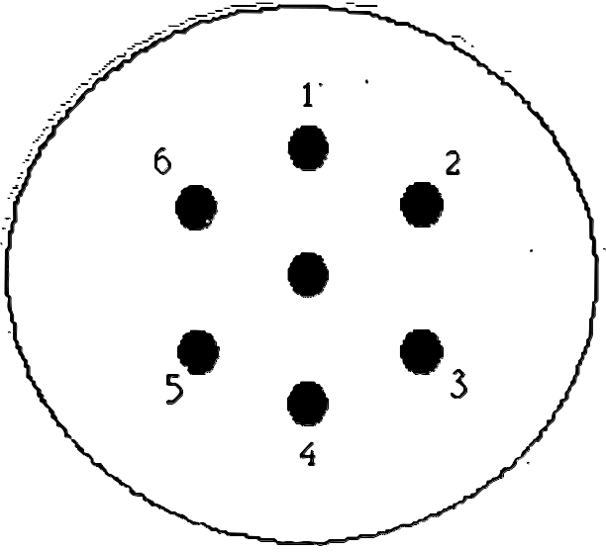

Template for cutting wells

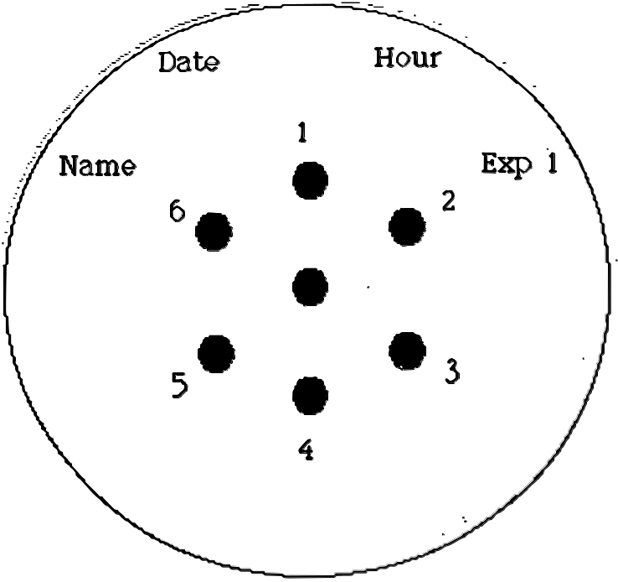

Fill the wells as fo11ows:

Well number Solution

1
2
3
4
5
6
Center well
saline
egg white I
egg white I I
Stan's salad solution
egg -enriched pasta solution
regular pasta solution
antibody

Well number Food Solution Precipitin Line (+/-)

1
2
3
4
5
6

Discussion
1. Based on your results, did Stan's pasta contain egg? Explain how you reached this conclusion

- Using the scientific terms from this lesson, explain the result you observed with the unknown.

3. Explain why it was important to test each of the following substances listed.
a. saline

b.egg white

c. egg-enriched pasta

d. regular

e. Stan’s pasta

Extension Questions

1, Explain the following terms in your own words:

- antigen

- antibody

- diffusion

- precipitin line

- allergy

2. Application: A woman has fever, a red rash, and aching joints. Her doctor cannot identify her disease. He takes a blood sample and sends it to the pathology lab at St. Louis University for immunology testing. The results are diagrammed below:

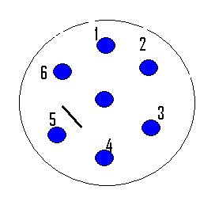

Well # Solution prepared from

1 Streptococcus bacteria
2 Swine flu virus
3 Tuberculosis bacteria
4 Cold virus
5 Lyme tick Rickettsia
6 Saline
center well Blood serum

2a. Which wells contain the antigens?

2b. Which well contains the antibody?

2c. Which disease does the woman have?

- Timber rattlesnake venom is injected into a horse. The horse produces antibodies against the timber rattlesnake venom. Blood is removed from the horse and the antibodies are purified. An Ouchterlony test (double diffusion gel) is performed to prove that the purified antibody does react against timber rattlesnake venom. Draw lines on the template to show the expected results.

1 Saline

2 Australian Tiger Snake

- Bushmaster (S. America)

4 Timber Rattlesnake (N. America)

5 Coral Snake (N. America)

6 Puff Adder (S. Africa)

- If in the above test with the horse antibodies and snake venoms, a precipitin line occurred between both 5 and the center well AND 4 and the center well, what could explain this result?

5. Hepatitis is a liver disease transmitted by blood transfusion, dirty needles, and drinking water contaminated by sewage. Suppose 5 patients are admitted to the hospital. You decide to test their blood serum to determine if they have antibodies against the hepatitis virus using the double diffusion (Ouchterlony) technique you used in this lab. Use the template below to show what substances you would place in each well. What would you expect to see if a patient did have antibodies against the hepatitis virus in his/her blood serum?
1
2
3
4
5
6
Center well

