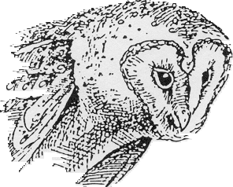 Owl Pellets

Standards:
3.2.10 B Apply process knowledge and organize scientific and technological phenomena in varied ways.
- Describe materials using precise quantitative and qualitative skills based on observations.
4.3.10 C Explain biological diversity as an indicator of a healthy environment.
- Analyze the effects of species extinction on the health of an ecosystem.
4.6.10 A Explain the biotic and abiotic components of an ecosystem and their interaction.
- Explain energy flow in a food chain through an energy pyramid.
3.3.7 A Describe the similarities and differences that characterize diverse living things.
- Explain how to use a dichotomous key to identify plants and animals.
3.7.7 B Use appropriate instruments and apparatus to study materials.
- Select appropriate instruments to measure the size, weight, shape and temperature of living and non-living objects.

Introduction:
Owls are raptors, predatory birds that actively hunt at night for other animals. Seven species of owls live in Pennsylvania, and the snowy owl sometimes visits during the winter. Barn owls, the subject of this study, stand about 15 inches tall, and are our third largest resident owl. Barn owls are brown in color with lighter underparts and a white heart-shaped face. They, along with the barred owl, are the only owls with brown eyes (the others have yellow) to live in our state.
OWLS: order Strigiiformes, Barn Owls: family Tytonidae, genus Tyto, species alba
Barn owls, as their name suggests, nest in barns, silos, old buildings, church steeples, and hollow trees. They usually lay 5-8 eggs in the early spring which hatch in 30-31 days. Both parents capture prey for the young owlets that can eat their weight in meat every night. Young owls fledge the nest at 9-12 weeks of age.
The open fields of farm country are the favored hunting habitat for barn owls. There, they capture mice, voles, rats, shrews, and an occasional bird. Prey are caught and kept from escaping with the sharp claws or talons at the tips of the owl’s feet. Small prey can be killed by the talons, but larger prey are killed by the owl’s powerful beak that crushes their head or breaks their neck. Although owls have excellent low-light vision, they cannot see in the dark. Much of their hunting is done by hearing. Their flight is nearly silent.
Owls swallow their prey whole or nearly whole. Once in the stomach, protein-digesting enzymes break down the soft parts of the prey and the nutrition is absorbed. The undigested remains (bones, fur, and feathers) from the night's hunt are regurgitated as a solid pellet about 20 hours later. Since barn owl pellets are usually dropped inside buildings they remain intact for many months.
At first glance owl pellets look like assorted sized pieces of feces, but close inspection reveals a mass of bones and hair. Since the bones are usually intact, prey number and species can be identified by using a skull key. No better way has been found to study an owl's diet.

Guiding Questions:

Vocabulary:

Materials:
For each pair of students: Class Materials:
One owl pellet Pellet display
Two teasing needles Owl posters
One zip-Loc plastic bag Clear tape
Lab write-up Video “The Barn Owl-An Introduction
Data sheets to Owl Pellet Labs”
One plastic petri dish

Safety Notes:
1. Teasing needles are very sharp. They are not toys and must be handled with extreme care.
2. Although these owl pellets have been sterilized, students should work on top of dissecting pans and wash hands before leaving the classroom.

Procedure:
- Work in pairs as directed by teacher.
- Obtain an owl pellet. Remove the pellet from the aluminum foil.
- Weigh the pellet and record the weight.
- Measure the pellet and record. Length________mm, Width _________mm
- Place the pellet in a dissecting tray or pan. Carefully separate the bones from dried fur or feathers using a teasing needle. Place the bones in your petri dish.
- Carefully clean the bones and sort them according to type: skulls, jaws, vertebrae, etc.
- When you are sure that all bones have been removed from the fur you may discard the fur and/or feathers.
- Identify the animals found in your pellet by comparing your skulls to the skulls in the picture key.
- Record the types and numbers of animals in the data chart below in the your data row

 | Vole | Shrew | Mouse | Rat | Mole | Bird
Your Data
Class Data

10. Record your data on the chart on the board.
11. When the last group has recorded their data on the board, copy the class data on to the chart above in the class data row.

Data:

- Construct a bar graph from the classroom data collected during day 1.
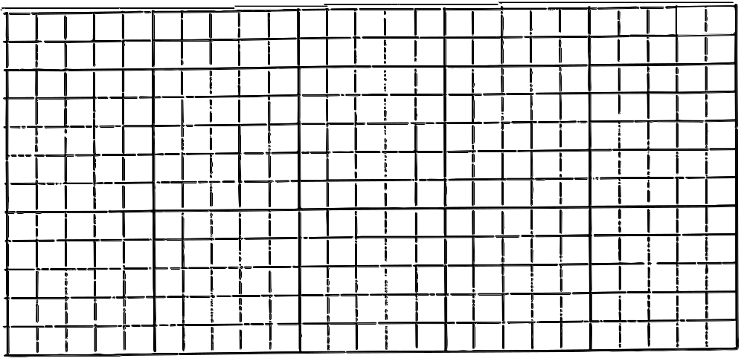

- Use your classroom data to calculate how many and what species of prey animals might be eaten by one barn owl in a year. Assume that an owl regurgitates one pellet per day. List your results below.

- How many prey animals (just the total number) would a pair of owls eat in one year?

- Using your classroom data, calculate what percentage of barn owl's diet would come from each of the following:

 | Voles | Mice | Shrews
Percentage

References:

Resource Manual for Owl Pellet Labs, James P. Key, White Owl Enterprises, 1996

Note: Most of the information in this lab was obtained from the PGC Wildlife Note "OWLS, the Night Hunters" by Chuck Fergus, as well as owl pellet study kits as sold by: Connecticut Valley Biological, Lat>Aids Inc. @ 1979, Nasco BioQuest @ 1991, Pellets Inc. (Science Kit & Boreal Labs)@ 1991, and Wards Natural Science Est. @ 1993.



