3 Ring Circuits

- Title: 3 Ring Circuits: Three activities introducing students to electricity

- Standards:
3.2.10.B4: Describe quantitatively the relationships between voltage, current, and resistance to electrical energy and power.
3.2.10.B6: Explain how the behavior of matter and energy follow predictable patterns that are defined by laws.
3.2.10.B7: Compare and contrast scientific theories; know that both direct and indirect observations are used by scientists to study the natural world and universe; identify questions and concepts that guide scientific investigations; formulate and revise explanations and models using logic and evidence; recognize and analyze alternative explanations and models.

- Introduction and background:
Electricity is the result of the movement of electrons. Electrons are the negatively charged particles that revolve around the nucleus of an atom. When enough electrical energy is added to electrons, they can escape from their normal orbit and flow along a path. The nuclei of the atoms stay in about the same place with the outer electrons moving through the conductor (wire). The flow of electric charge is called a current, but the path on which the charge flows is called a circuit (TechTopics, 2006). In our lab today we will work with electricity flowing in only one direction. The flow of electrons leaves the negative terminal and flows through the circuit to the positive terminal. We can change the direction of the flow of electrons by using switches. In this lab, you will make two kinds of switches: a single pole single throw switch and a single pole double throw switch.

- Guiding questions: What is electricity? What makes our electronic things work? How can we make electricity follow a path that we want? What can we do if the power requirements are too much or not enough?

- Vocabulary:
Circuit a closed loop
Conducting a substance that allows a current to flow through it with little resistance.
Insulating a substance that allows a current to flow through it with great resistance.
Light Emitting Diode a diode allows a current to flow in only one direction. A Light Emitting Diode allows current to flow in only one direction and emits light.
Resistance the impedance or slowing of an electrical current.
Single pole single throw switch a switch with only one choice (eg. off or on)
Single pole double throw switch a switch with two choices (eg. light or buzzer)
Voltage a measure of the flow of electricity.

- Materials (for each group of two students):

Insulating dough
Conductive dough
Two 9v battery
Two Snap-on 9v battery leads
Six 5 mm LEDs
Two small piezo buzzers with leads(1.5 – 3 v)
About 50 brass paper fasteners
About 50 small paper clips
Two pieces of cardboard roughly the size of a sheet of paper
Two plastic film canisters
Two toggle switches
Two pushpins
Two 3v coin cell batteries
Soldering iron and solder
Wire cutters/strippers
Doorbell wire

- Safety: The LEDs we are using are rated for less than 5v. DO NOT run the current straight from the 9v battery through the LED as it may shatter. Do not touch the battery with wet hands.

- Procedure (in the first ring):
- Use the insulating and conducting dough, the snap on 9v battery lead, a 9v battery and three LEDs to make a circuit. Be prepared to explain how your circuit works.
- Using electrical symbols, draw a circuit diagram of your dough circuit in the space below. (see Attachment A for explanation of electrical symbols)

- Procedure (in the second ring):

- Pick the place on your board where you want the battery. Place a paperclip on that spot and with the pushpin poke holes just inside the ends of the clip. Imagine that those holes are at 9 o’clock and 3 o’clock. Rotate the paperclip 90 degrees and poke 2 more holes at 12 o’clock and 6 o’clock. Push a brad through the left hole (9 o’clock) and another brad through a paperclip and through the right hole(3 o’clock). Now flip the board over.

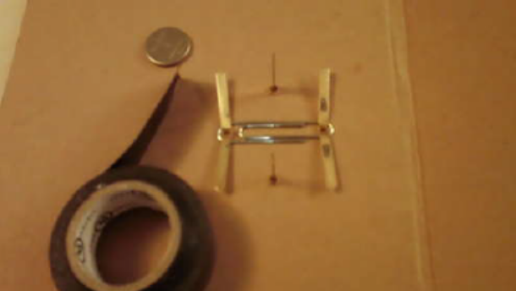
- Now on the back side place a paperclip over the 2 brads and secure it by flattening them out. This is your negative connection. (see pic) Place tape over the brad pins.
- Put brads in the top and bottom holes. The top (12 o’clock) needs a paperclip on the front. On the back you are going to sandwich the battery between the clip going left to right and the one going top to bottom. Make sure the battery is in the right way (positive side of the battery is up) and touching the top and bottom paper clips.
- Now secure it by spreading the brad pins and applying tape. (see pic)
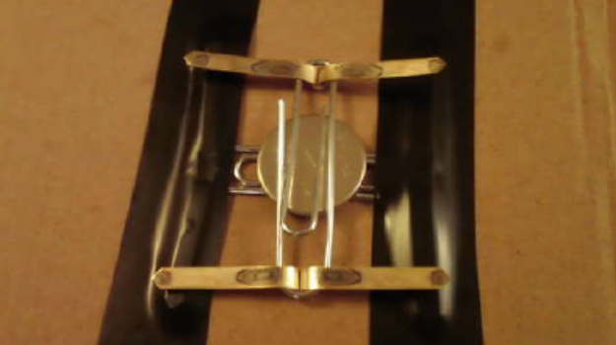
- Flip over the board so you see the front and test the clips with the LED. (The longer LED leg is positive)
- If the LED lights you can move on.
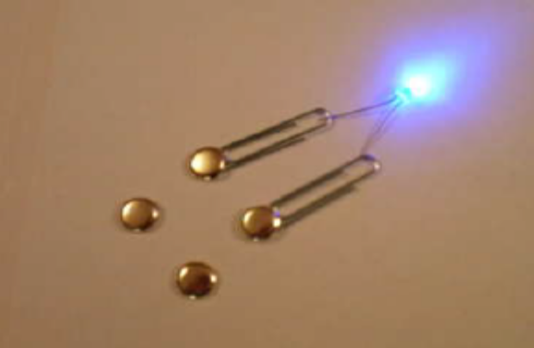

- The first paperclip coming off the positive pin (the top brad) will be used as an ON/OFF switch. So with that clip pointing up the board poke a hole through the end of it. Move it to the side and place a brad through another paperclip in the hole you just made.
- Now extend the "wire" continuing this process of lining up the paperclips, poking holes with the pushpin, adding another paperclip and brad. (see pic) 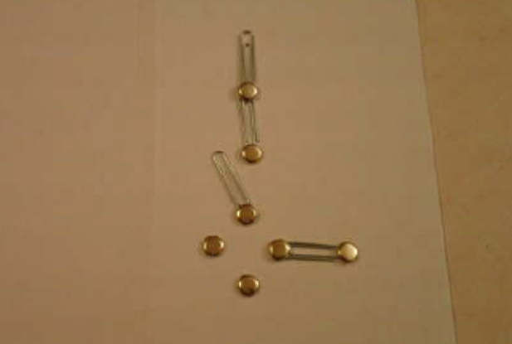
By now you should have gotten the idea of how to extend the "wire" by fastening the paperclips down with the brads. If not, the pictures should help.
You have just made a SPST (Single Pole Single Throw) switch.
- You will now make a SPDT (Single Pole Double Throw) switch. The left will be an LED and the right will be a buzzer. Place a brad on either side of the paperclip switch.
- Poke a larger hole for the LED above the left. The LED needs to be installed the right way. The positive lead/wire is longer than the negative wire. Now wrap the positive lead around the brad leg below it and the negative lead gets wrapped around the brad leg above it. (see pic)
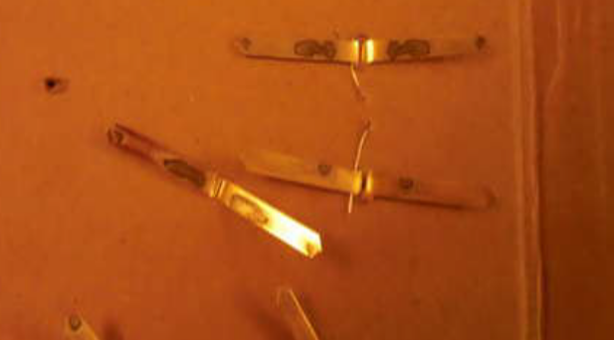
- Repeat this process on the other side of the switch with the buzzer. Poke a hole near the right side switch brad and pull both wires from the buzzer
through it. You may need to strip a bit more off the wire ends. Wrap the red wire end around that "switch" brad and the black wire can go around any brad that is beyond the LED. (see pic)
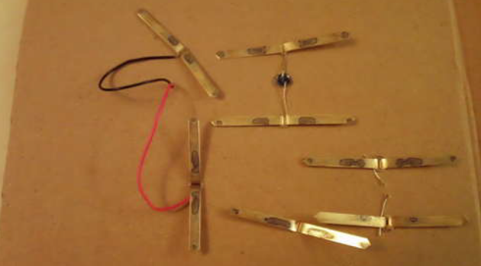
Use a bit of tape folded over to stick the buzzer to the board. It should look something like the pictures.
- Now the negative side the LED and buzzer should be connected to the top of the last "wire chain."
- Just add more "wire" to connect the sensors negative side down to the negative side of the battery.
- To use the switches move them over and pick it up a bit to place on the connecting brad.
- Test and make sure it works. Connect the first switch "ON." Then choose the LED. It should light. Now choose the buzzer and it should make noise.

- Procedure (in the third ring):
- Use the pushpin to make two small holes on the cap of the canister for the LED to go through. Put the LEDs through the holes so that the longer leg (which is the positive lead) is on the left.
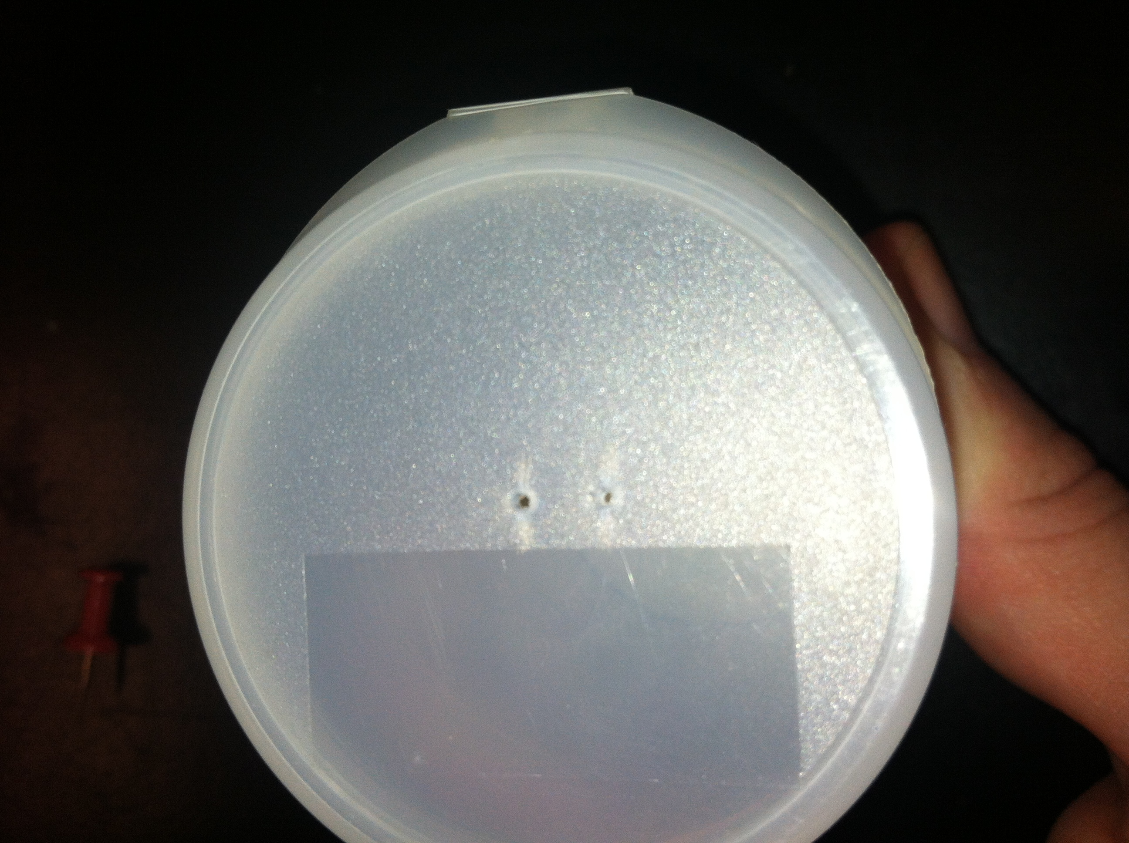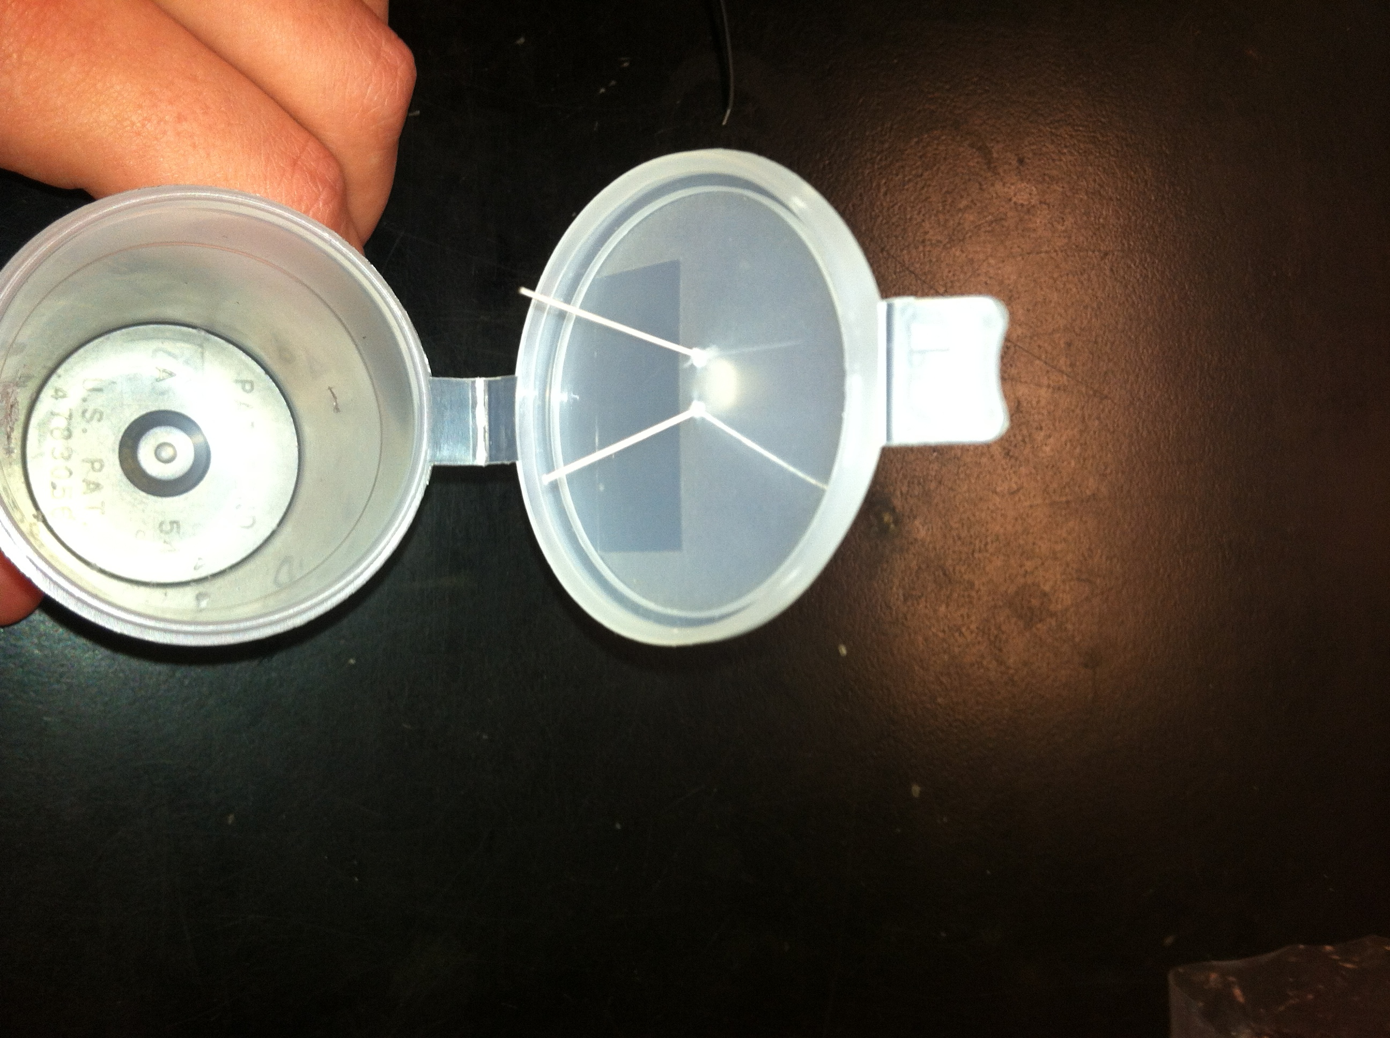

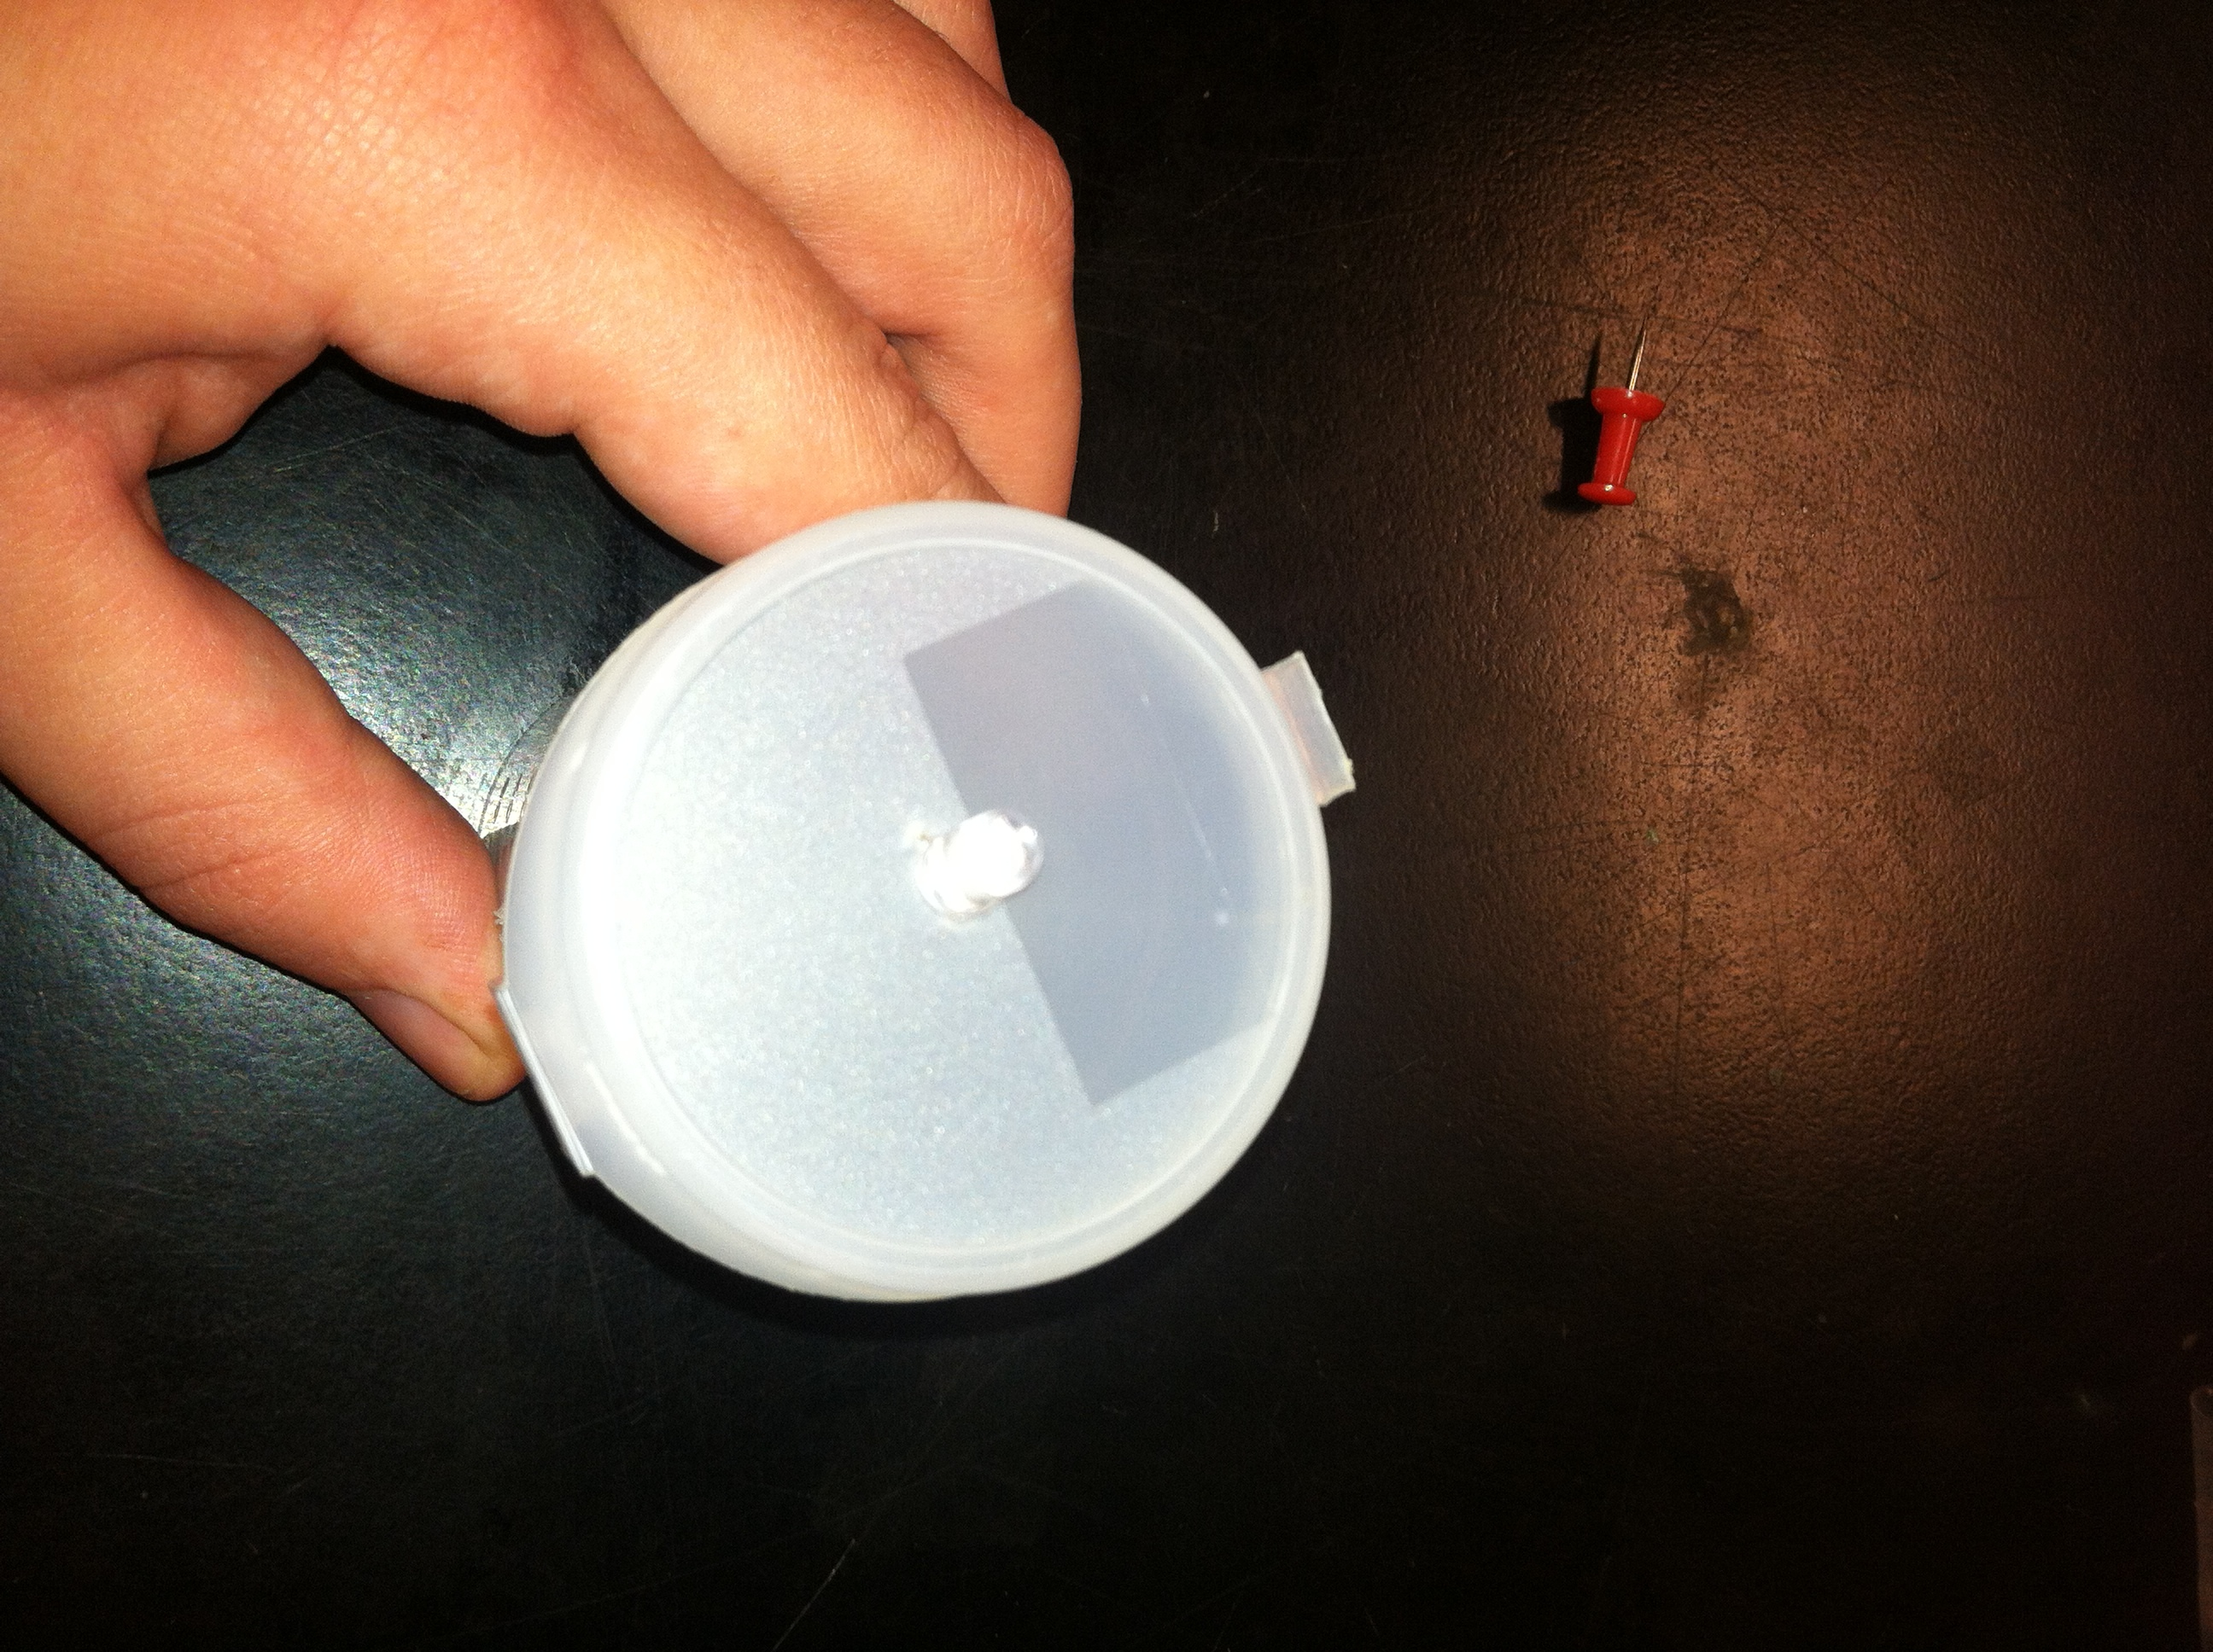

- Bend up the ends of the LED leads to make hook.
.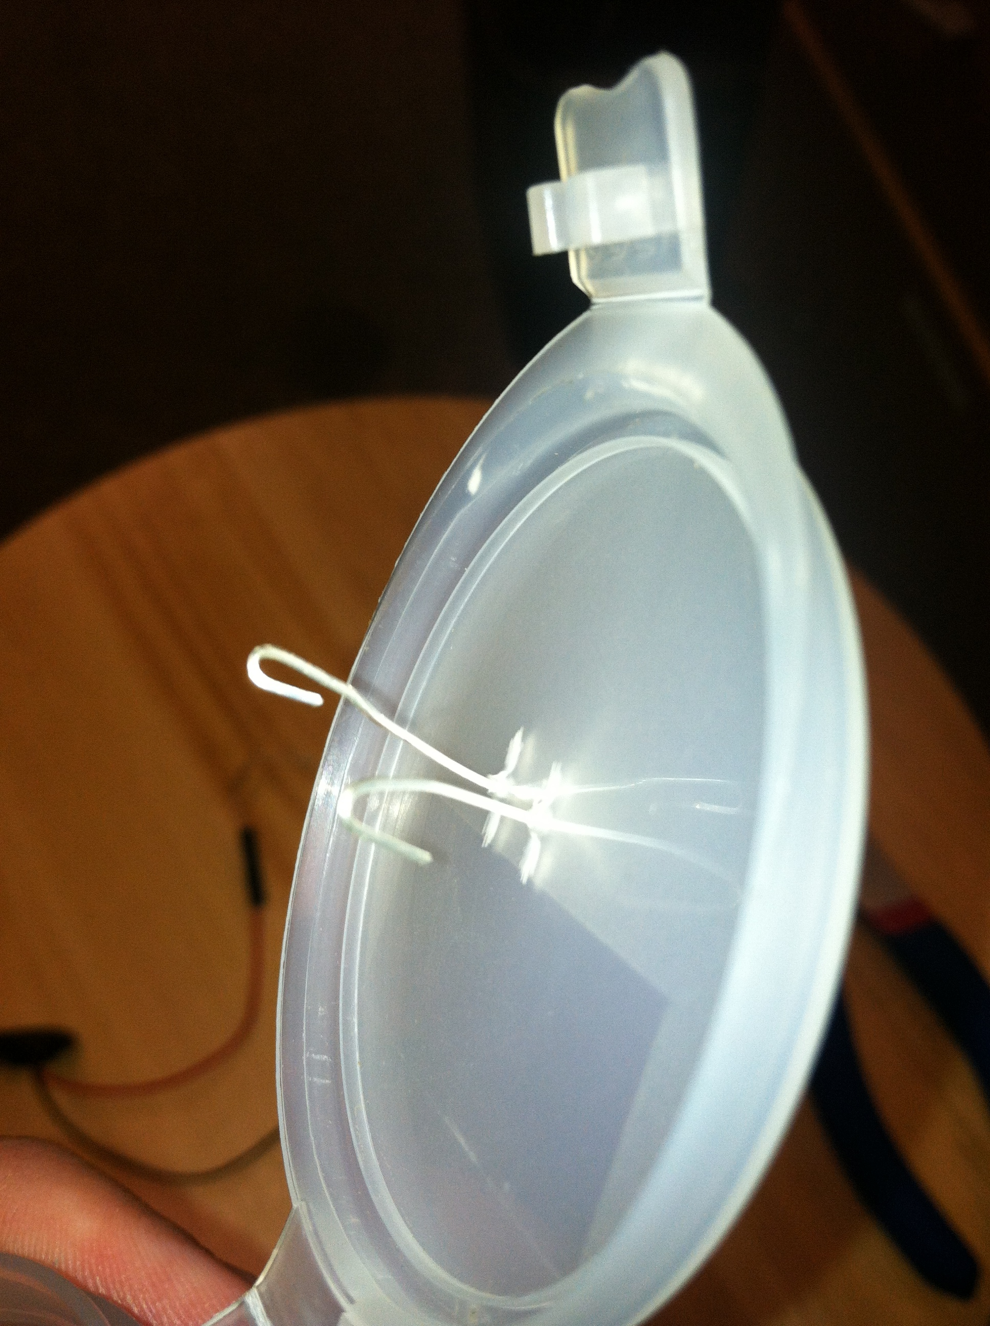
- Cut three pieces of bell wire about 8 cm long. Strip the insulation from the last 1 cm on each end of the wires.
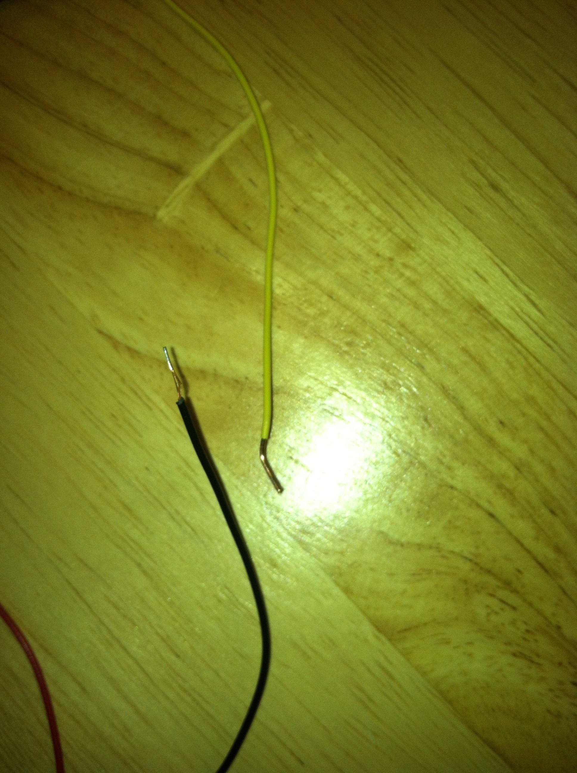
- Place one end of a wire through the hole on the bottom of one of the leads of the switch. Bend it into a loop so that it stays attached to the switch. Wrap tightly with electrical tape. Repeat with the other lead.
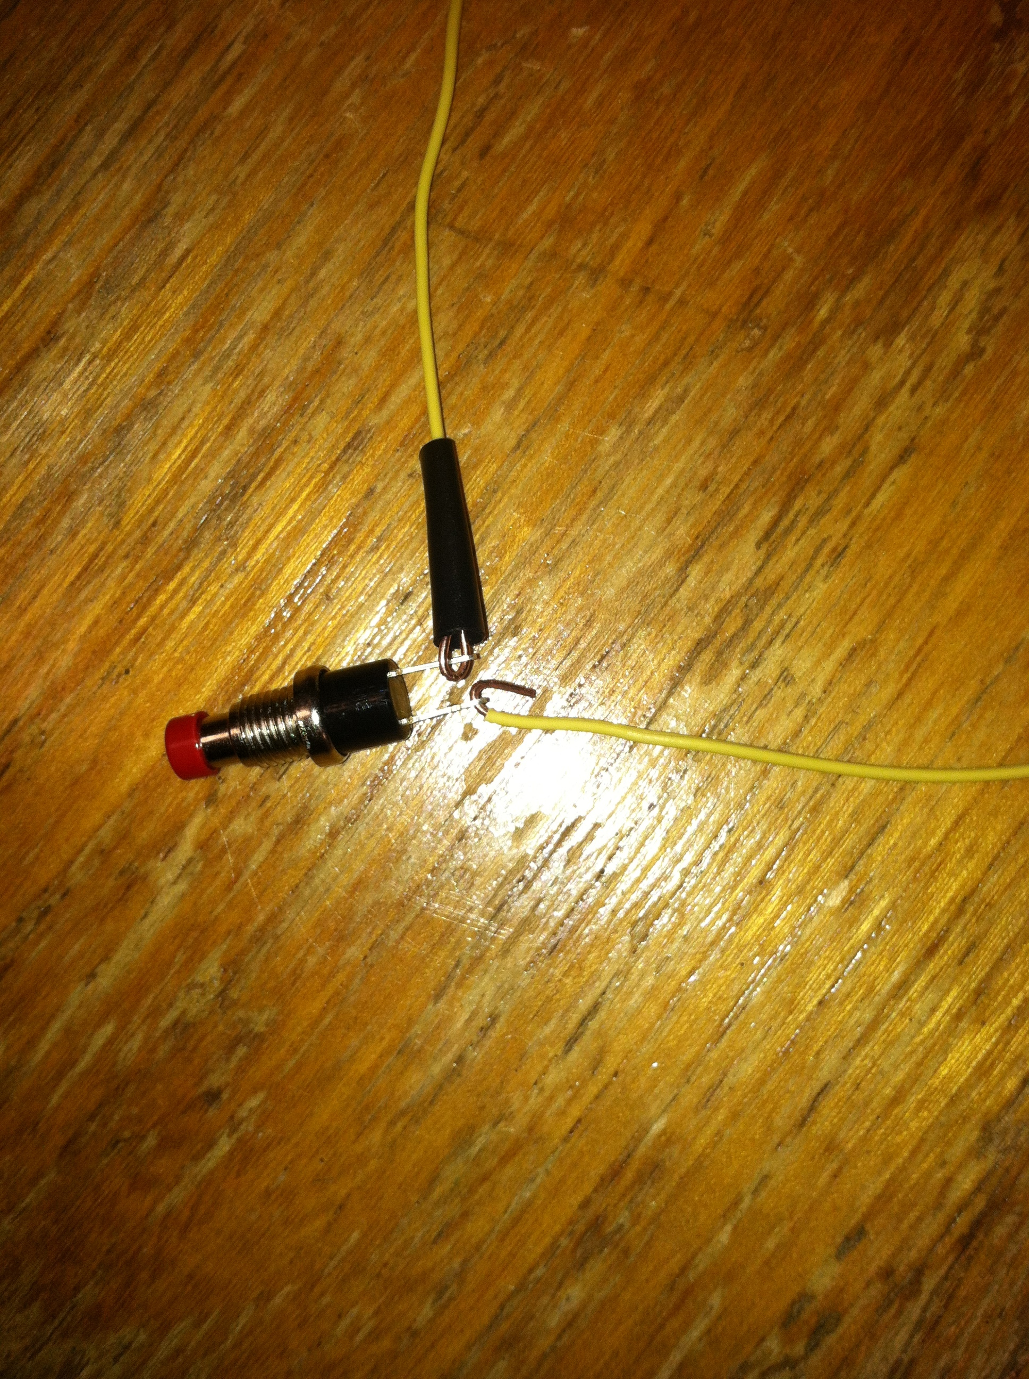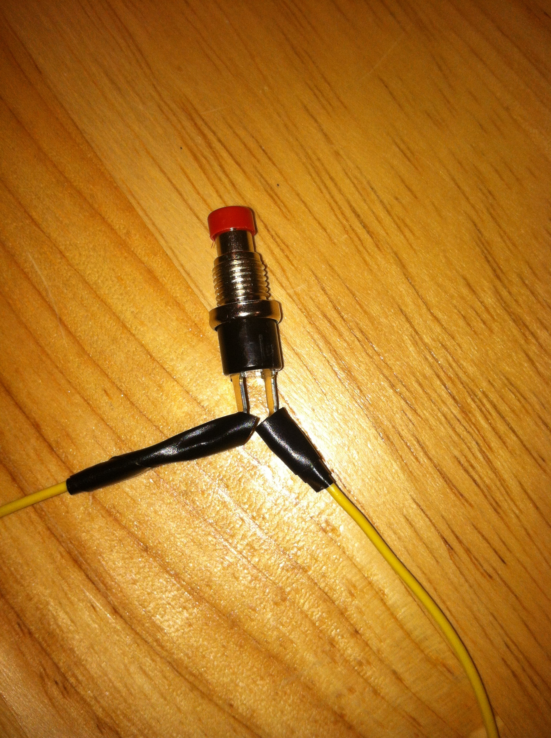
- Place switch into hole on container and tighten nut on outside to hold switch in place.
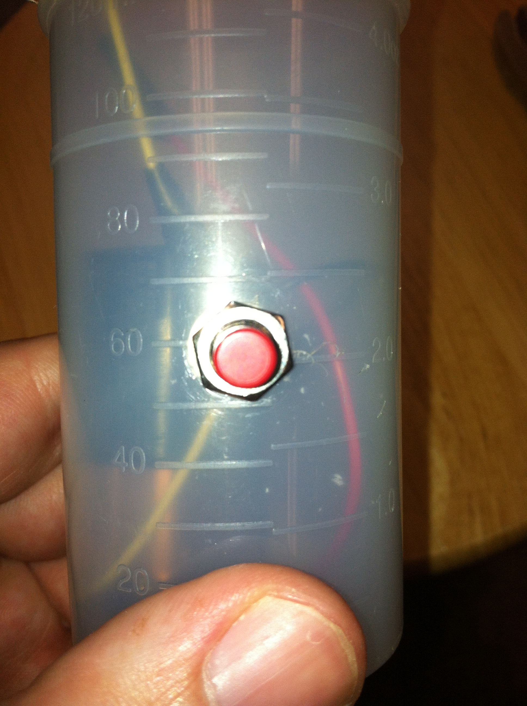
- Bend the end of the wire from one lead of the switch and hook it together with the negative lead coming from the LED. Use the pliers to tighten the connection. Wrap with electrical tape.
- Take the other wire from the switch bend the end into a hook. Take the black lead coming off the 9v snap top and bend its end into a hook. Hook them together and use the pliers to tighten the connection. Wrap with electrical tape. 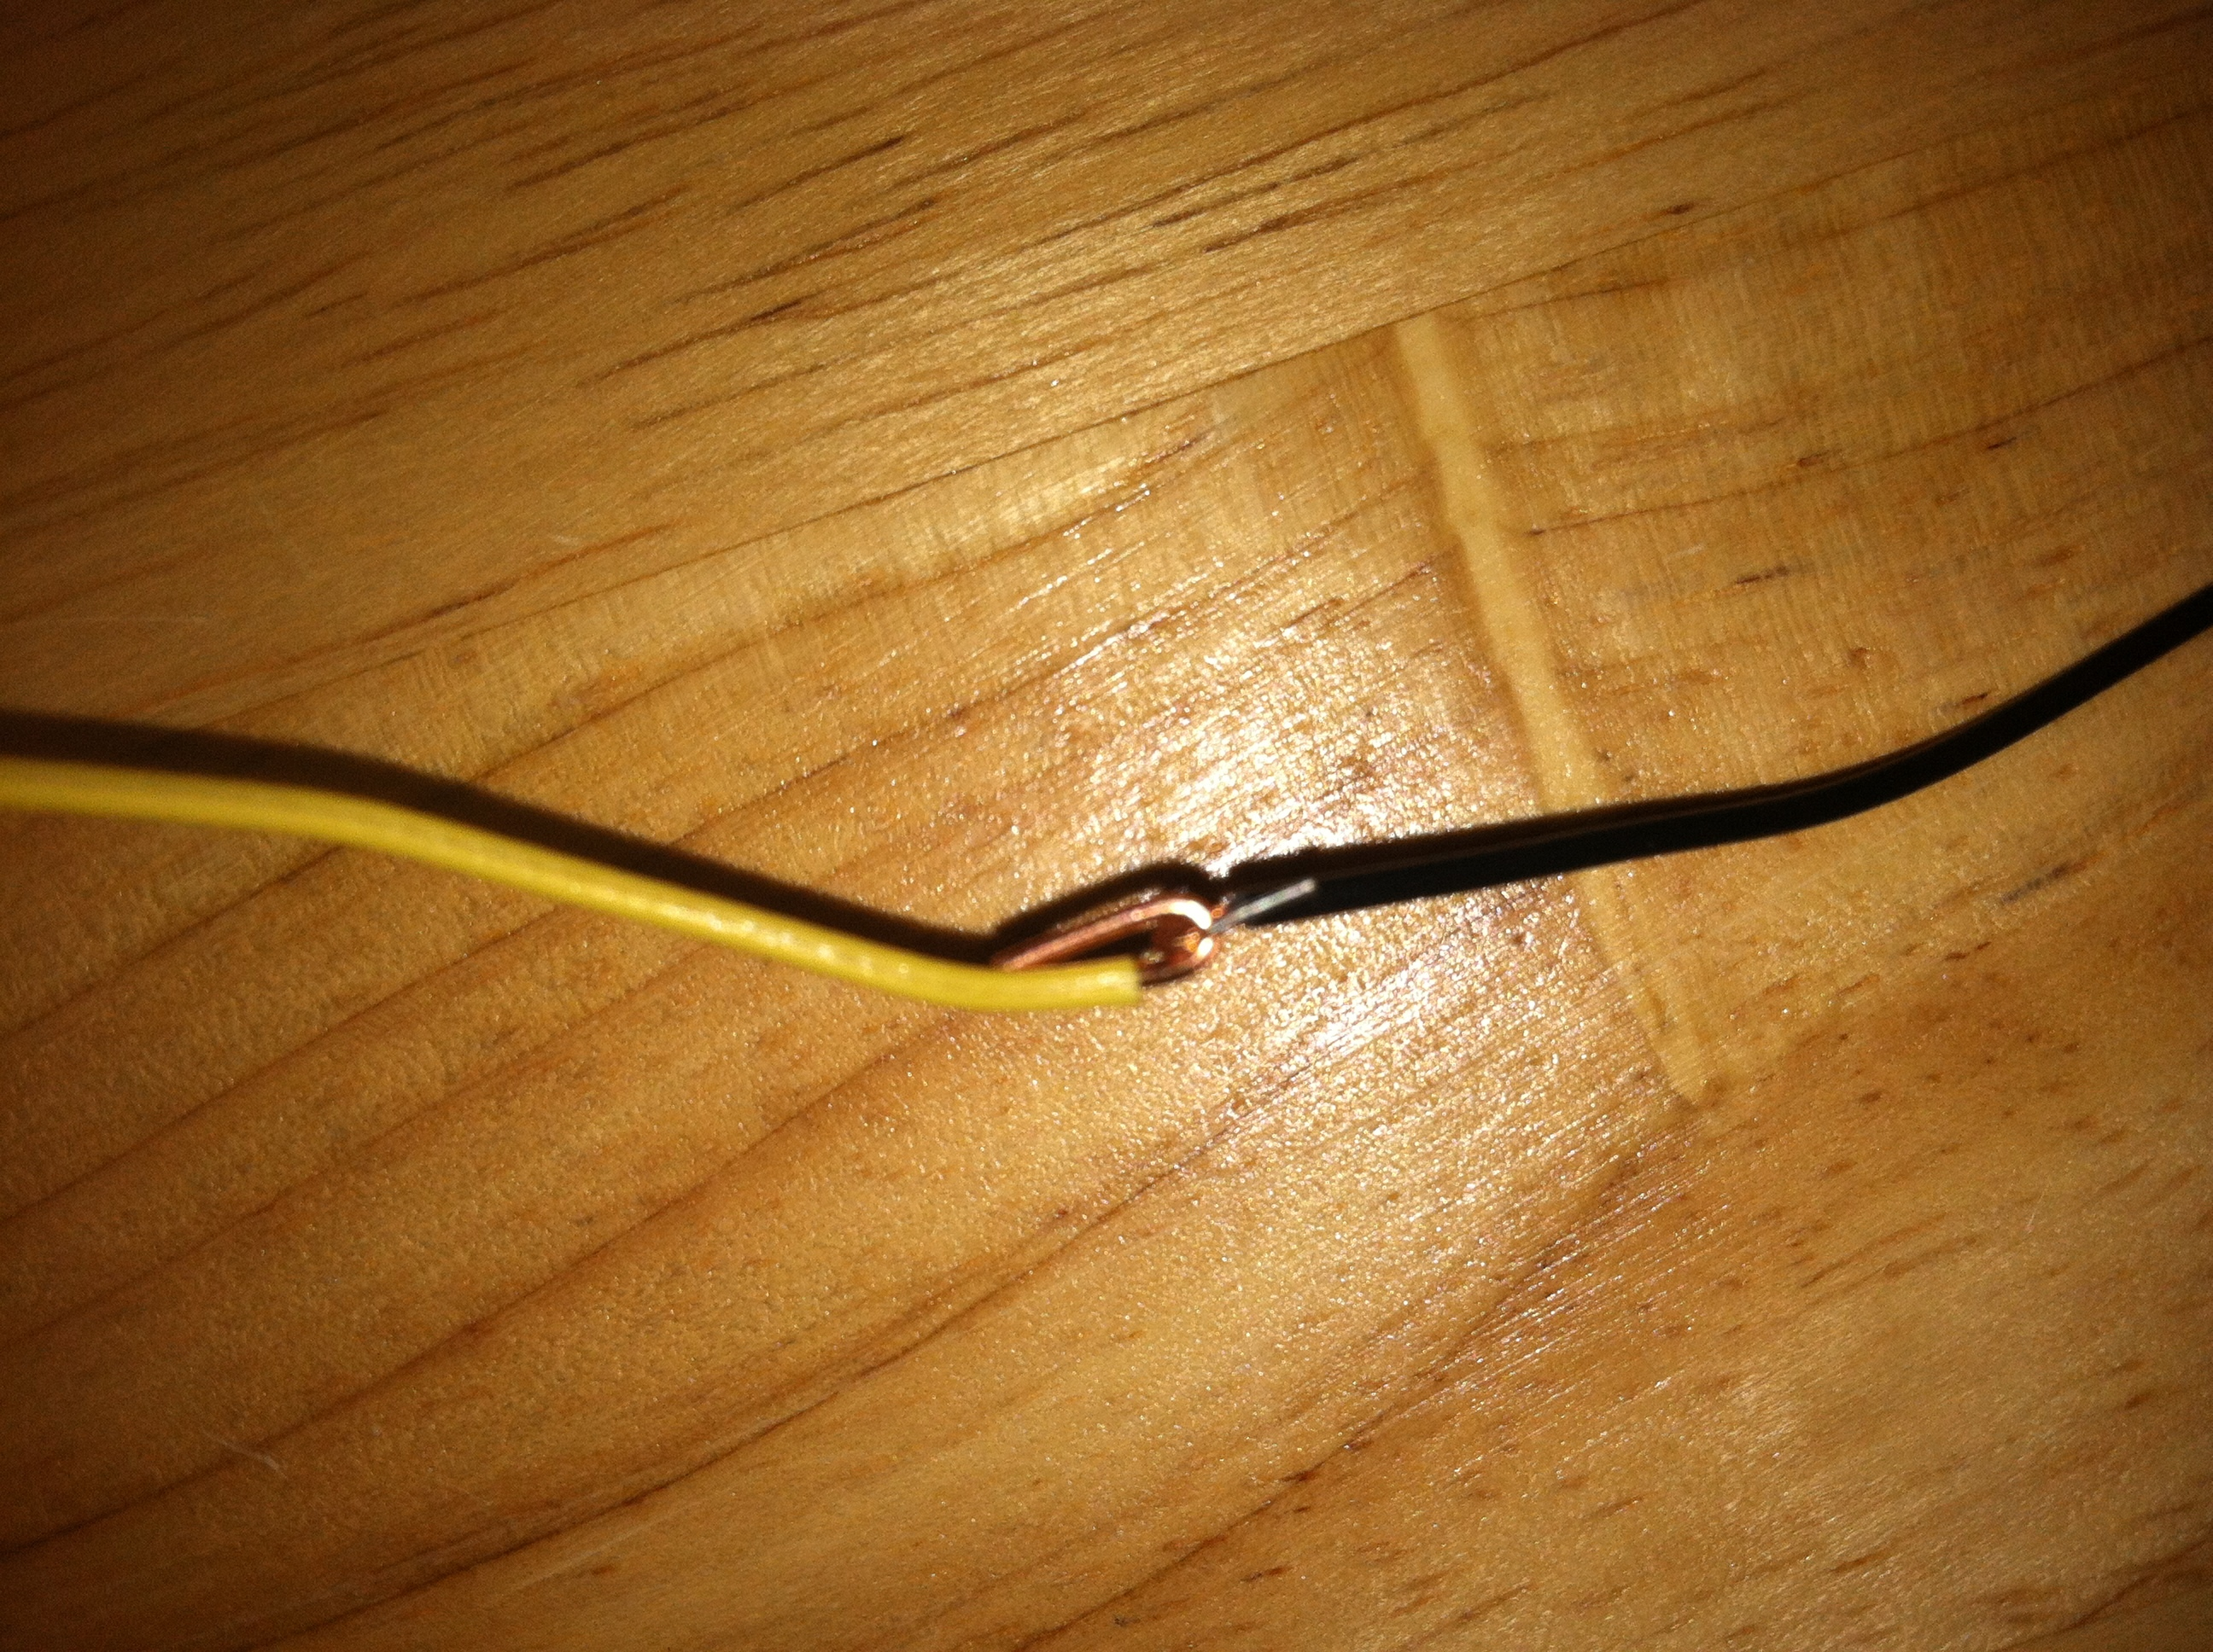
- Take the red lead from the 9v snap top and bend it into a hook. Bend both ends of the resistor into a hook. Hook one end of the resistor together with the red wire from the 9v snap top. Use the pliers to tighten the connection and wrap with electrical tape.
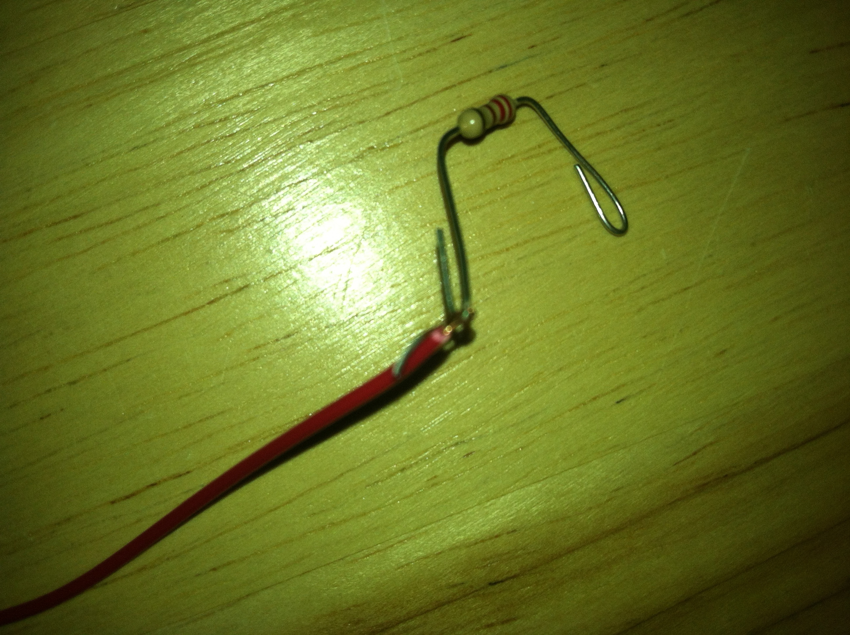
- Bend the other end of the resistor into a hook and hook it around the positive lead of the LED. Use the pliers to tighten the connection. Wrap with electrical tape.
- Snap the 9v snap cap onto the top of a 9v battery making sure the positive and negative terminals are lined up correctly. Place all wires and battery into the container. Close the lid on the container.
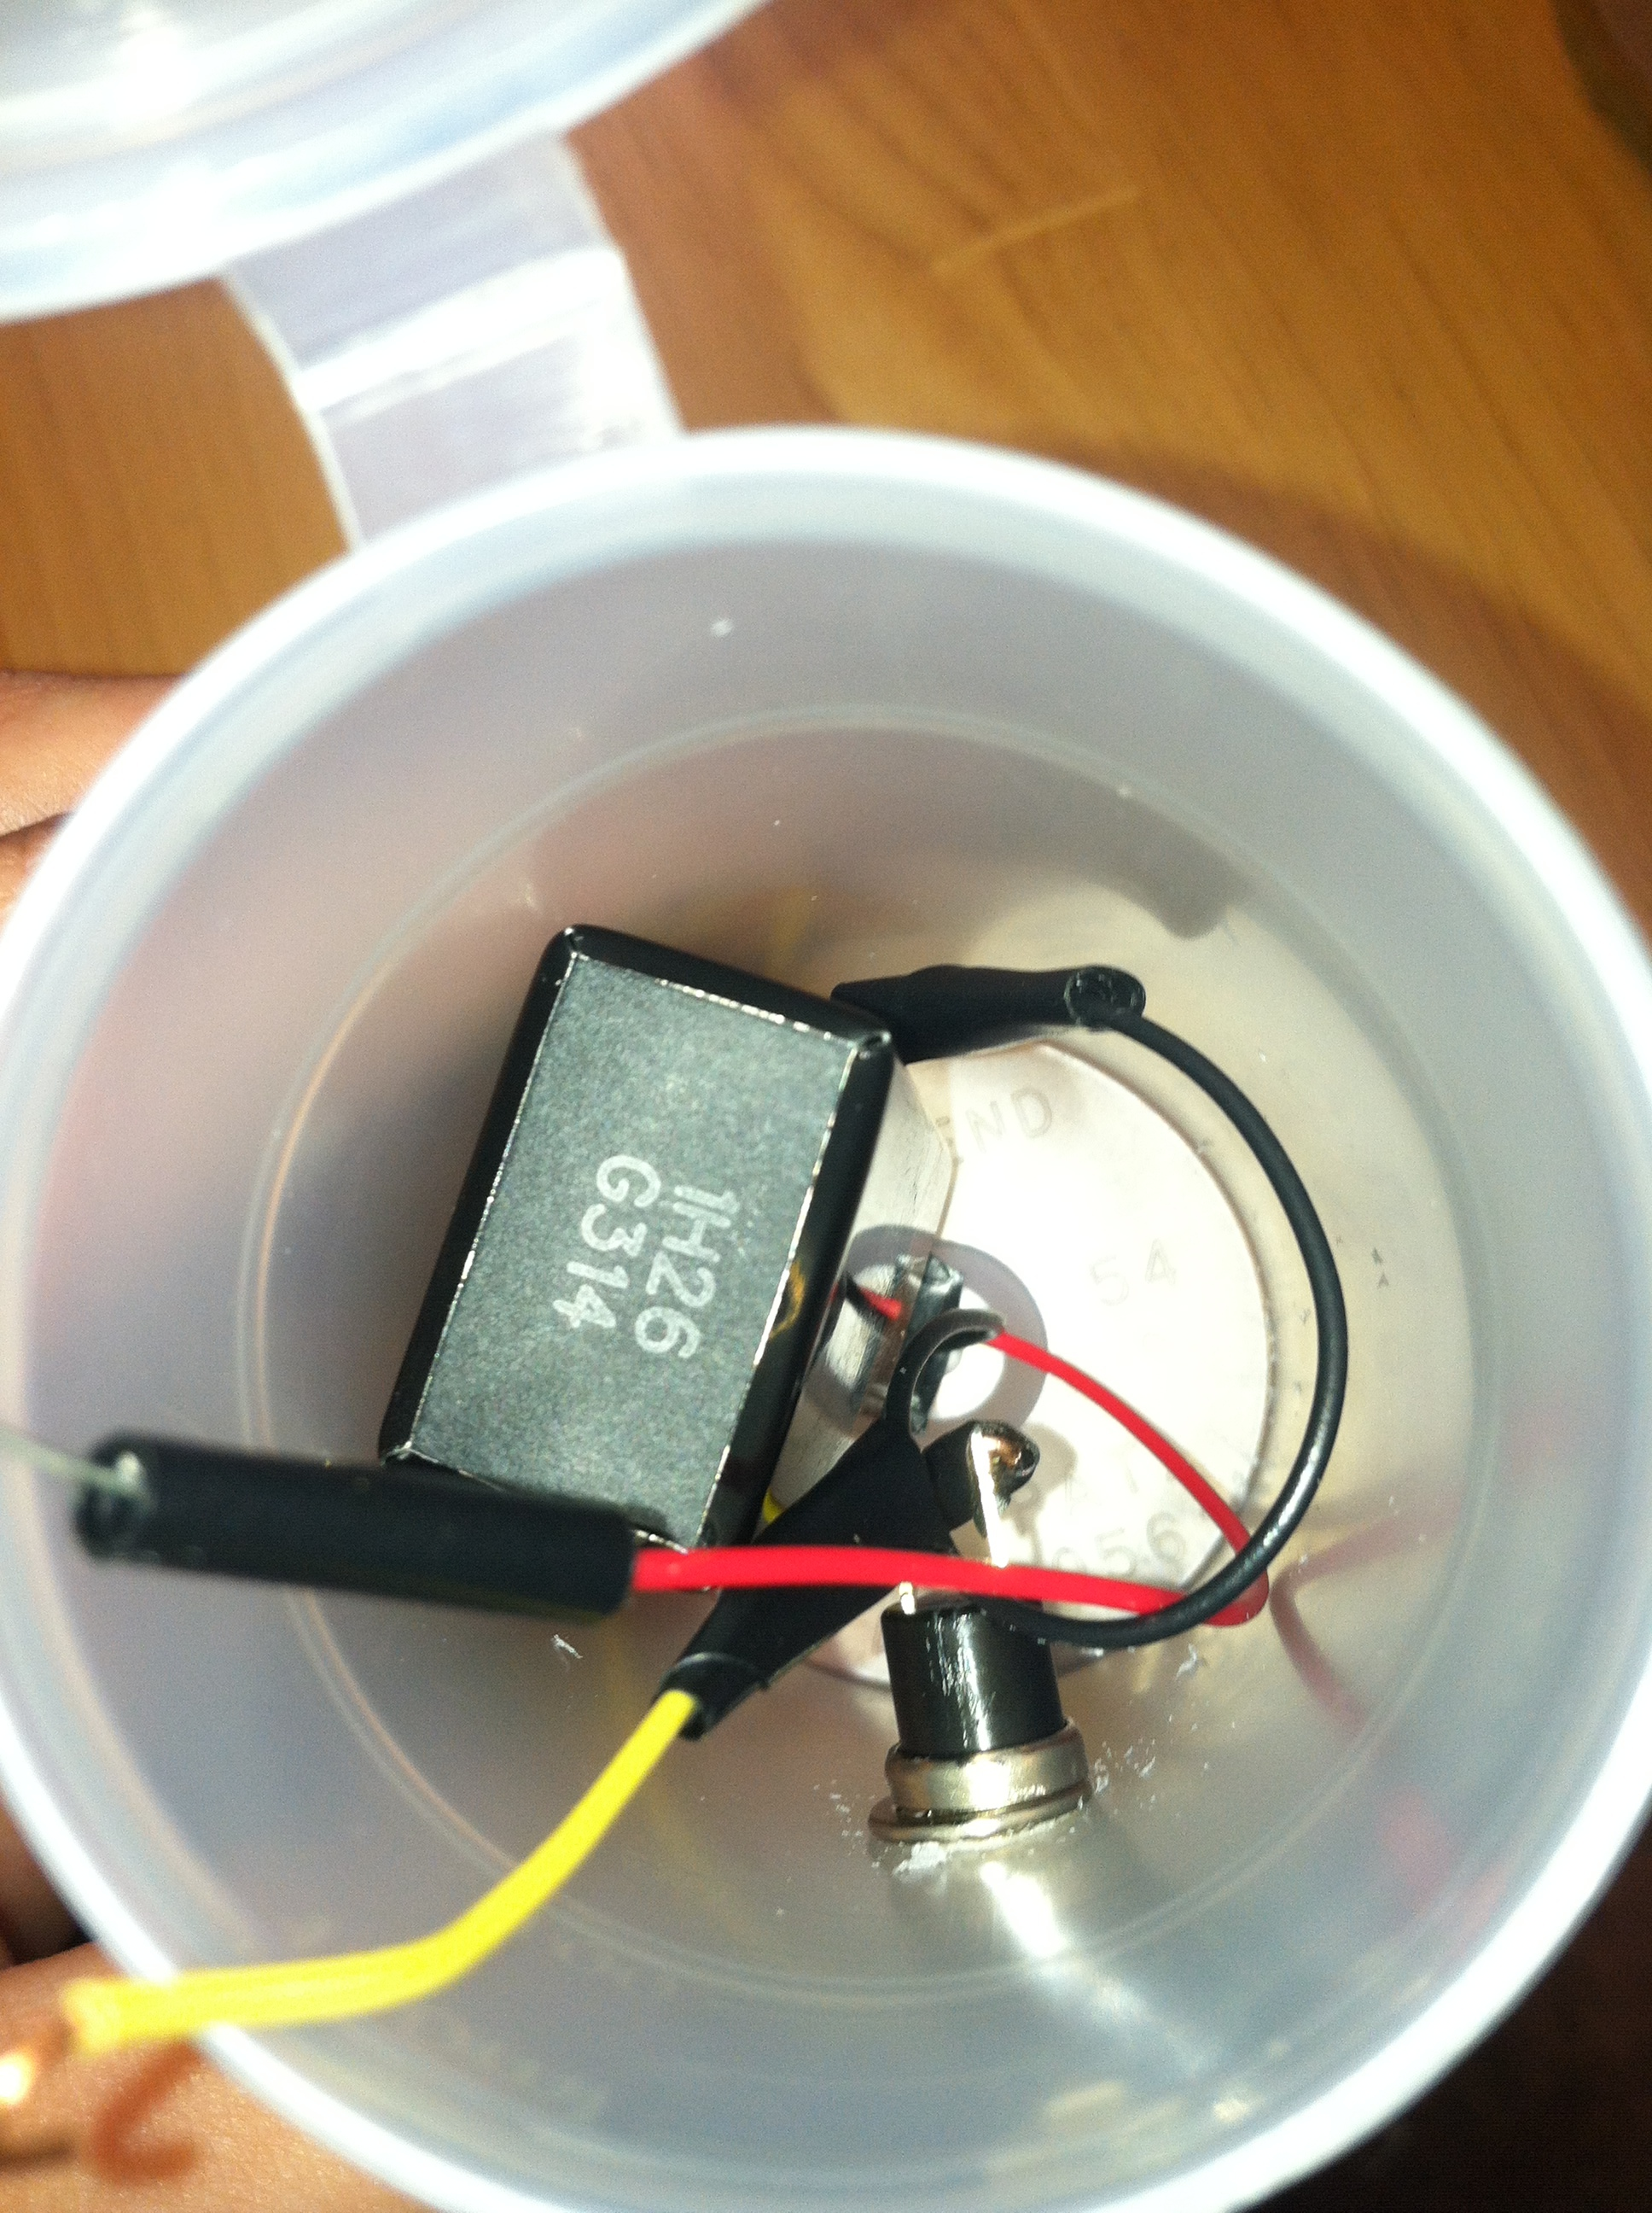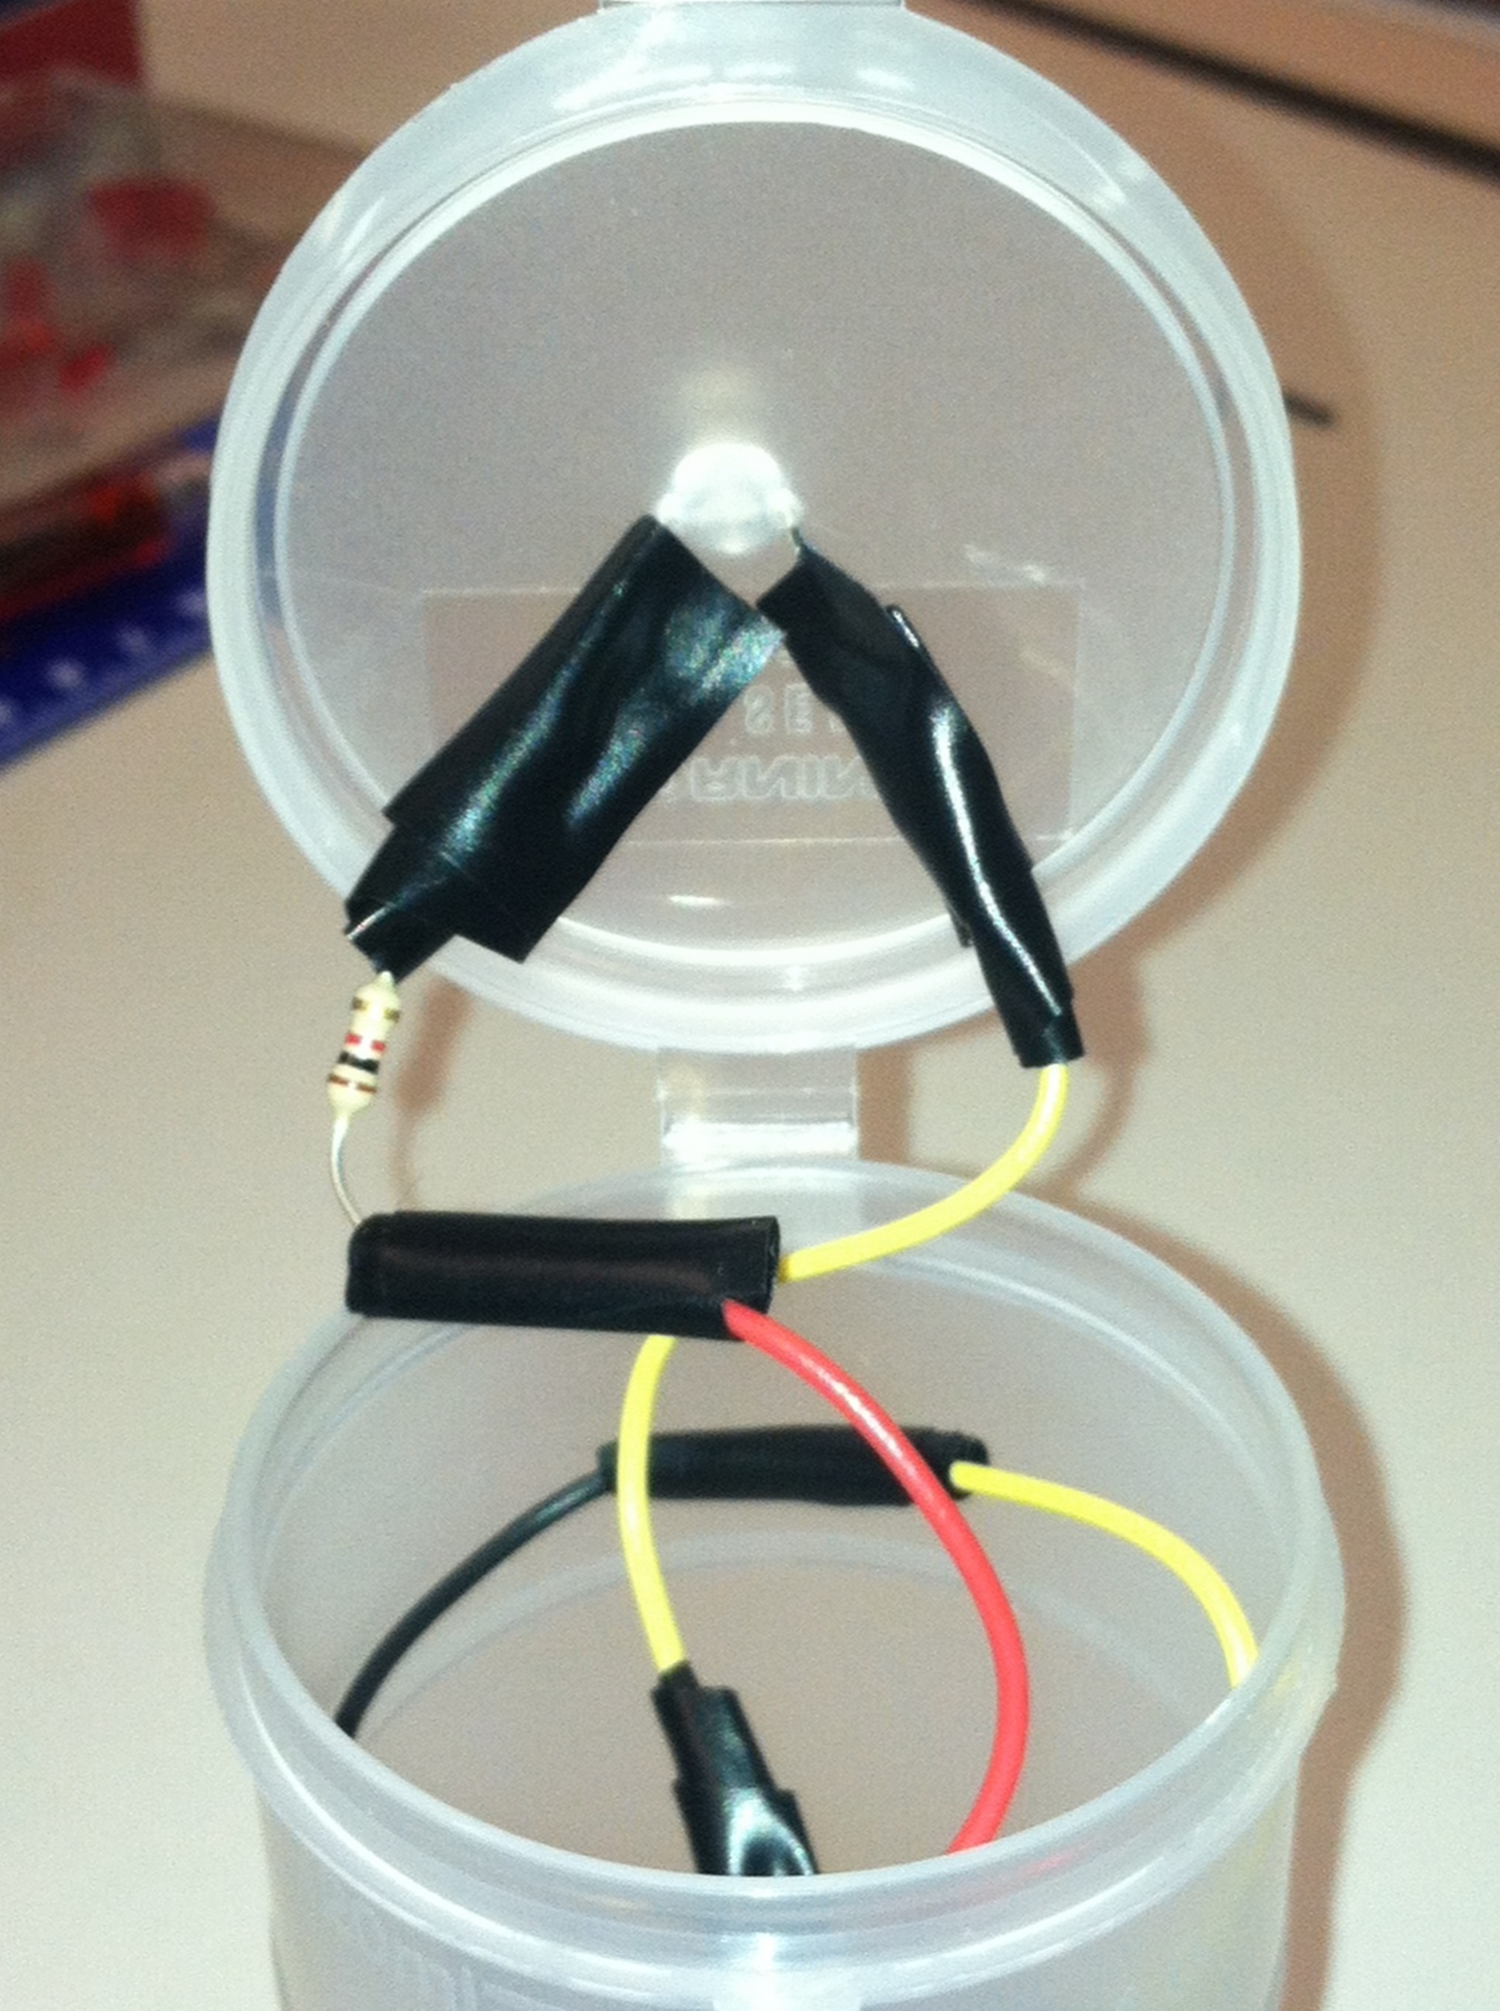
- Press the button on the outside. The LED should light. If the LED does not light, check your connections to be sure that they are tight.
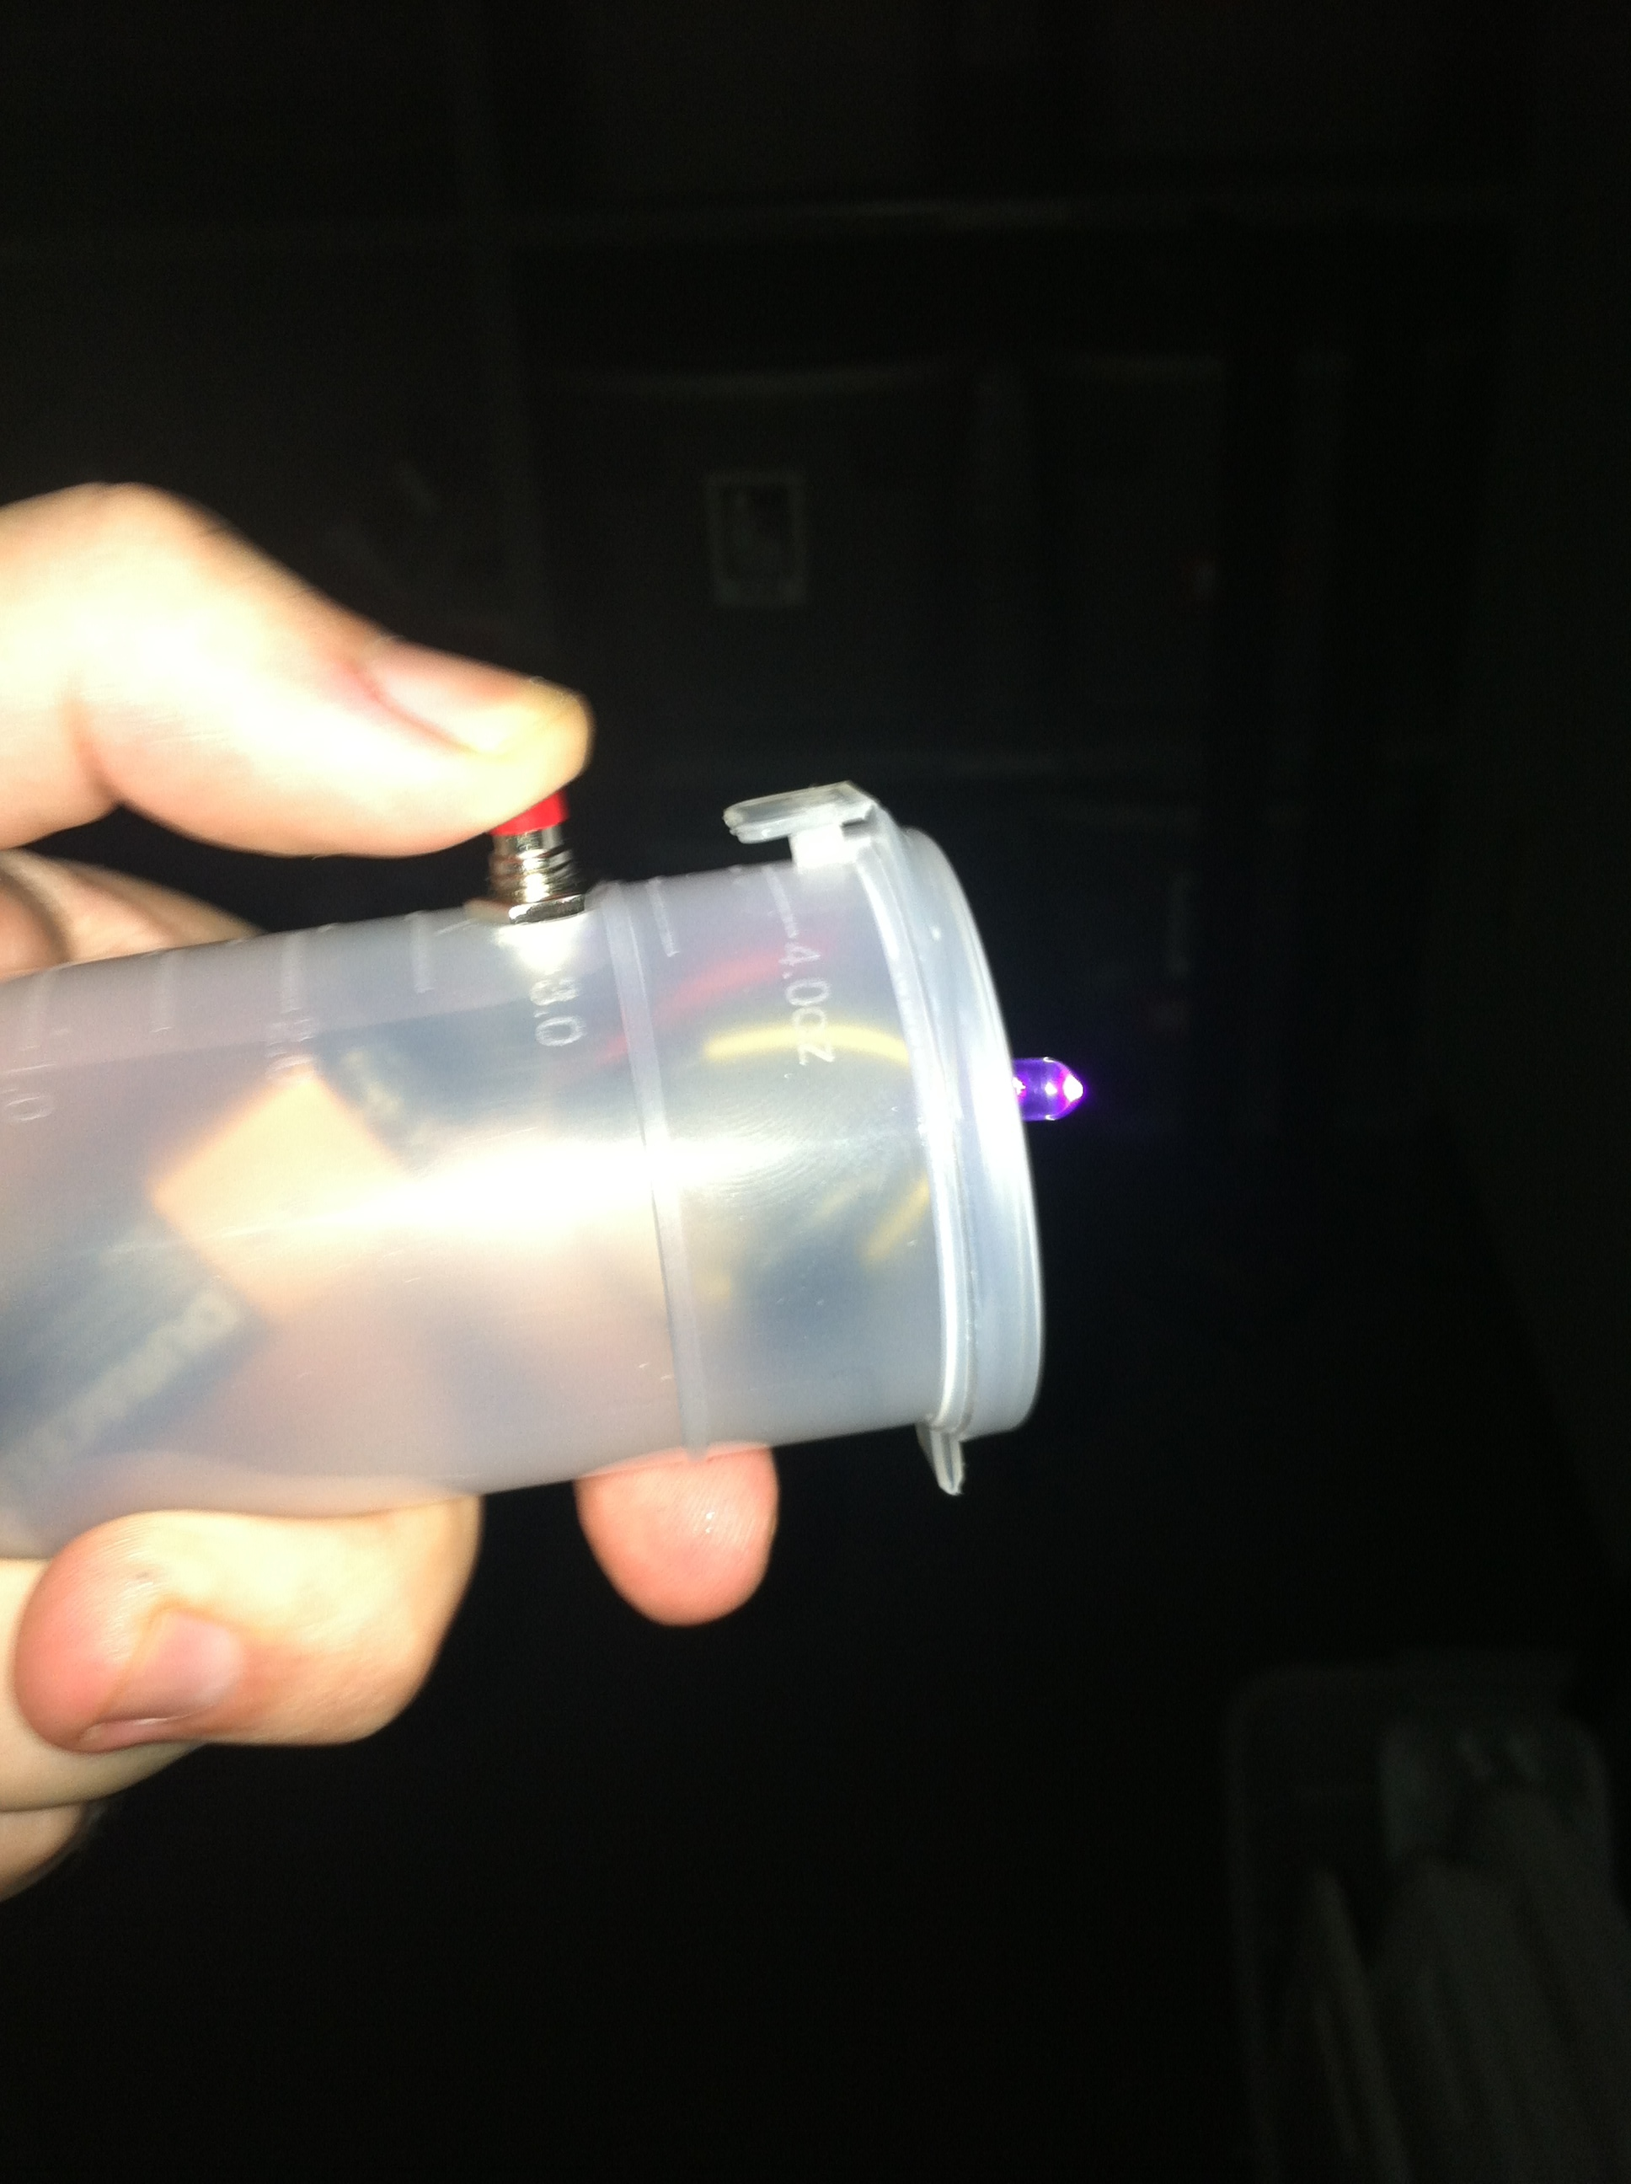

- Questions:
How can you change the flow of electricity in a circuit?

What is a switch and how is it used?

- References:
Squishy Circuits. 2011. “Making Conductive Dough”. 03 July 2012. <http://courseweb.stthomas.edu/apthomas/SquishyCircuits/conductiveDough.htm>

Squishy Circuits. 2011. “Making Insulating Dough”. 03 July 2012. < http://courseweb.stthomas.edu/apthomas/SquishyCircuits/insulatingDough.htm

Instructables. 06 Dec 2011. “Build a Simple Circuit from a Pizza Box (No Soldering)”. 03 July 2012. < http://www.instructables.com/id/Build-a-Simple-Circuit-from-a-Pizza-Box-No-Solder/>

Instructables. 21 Apr 2008. “Film Canister LED Flashlight”. 03 July 2012. < http://www.instructables.com/id/Film-Canister-LED-Flashlight/>

Attachment A

Electrical Symbols

Wire
Junction
Bulb
Resistor
Power
Switch (open)
Switch (closed)
Single pole double throw switch

Buzzer

