Cookie Science Investigation: Finger Print Worksheet
Compare the counselors’ finger prints to the finger prints found on the glass of milk. There may not be an exact match, but try to eliminate suspects from your list.

 | Left Index | Left Thumb | Right Thumb | Right Index
Suspect 1

Suspect 2

Suspect 3

Suspect 4

Suspect 5

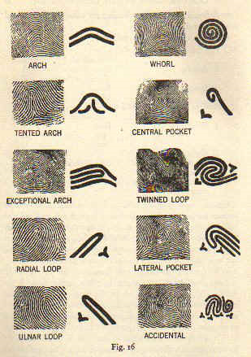
<http://www.johnnyfincham.com/history/dg.patterns.jpg>
*Note: For the Radial and Ulnal Loops, the bottom of the start of the loop is in reference to the radius and ulna bones of the lower arm. When looking at your hand (palm up) the radius is on the outside.
Suspect(s):

